### **Fougito Restaurant Dedicated Website**

### **Order flow**

#### **1. Home Page**

* **Homepage Overview**:
  + The home page features several options:
    - **Order Here**: Start the ordering process.
    - **Trending Categories**: View popular categories.
    - **Meal Plan**: Explore meal planning options.
    - **Track Order**: Monitor your current order status.
    - **Our Menu**: Browse the entire menu.
    - **Contact Us**: Reach out to the restaurant.
    - **Available Coupons**: Check for active coupons.
    - **Recent Reviews**: Read recent customer reviews.
    - **Table Reservation**: Book a table at the restaurant.
    - **Feedback**: Provide feedback about your experience.

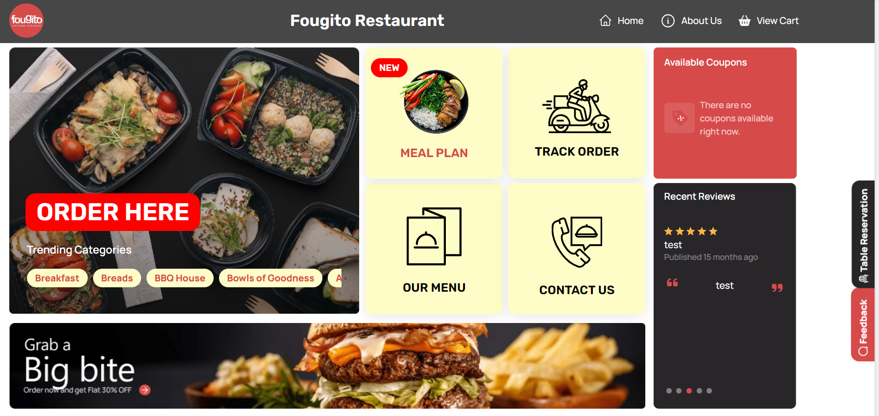

#### **2. Click "Order Here"**

* **Order Here Page**:
  + After clicking "Order Here," users are presented with two options:
    - **Switch to Pickup**: For orders to be picked up at a restaurant branch.
    - **Switch to Delivery**: For orders to be delivered to a specific address.

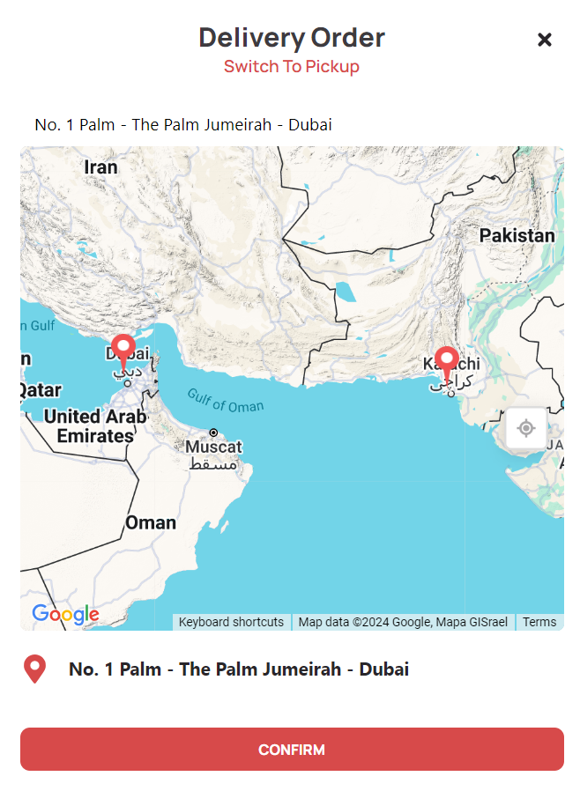

#### **3. Switch to Pickup**

* **Branch Selection**:
  + **Select a Branch**:
    - Users see a list of all available branches, each with its address.
    - Users select the branch where they want to pick up their order.

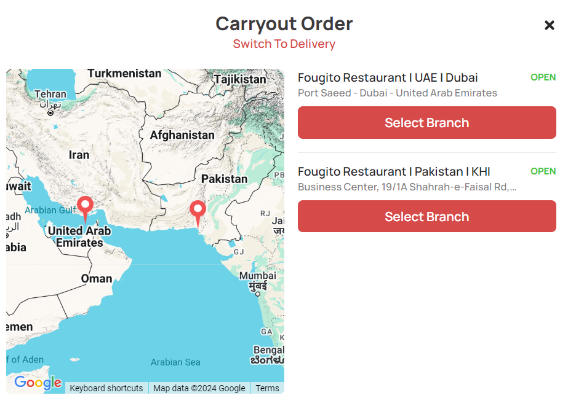

* **Branch Details**:
  + **Menu Display**:
    - The website displays the menu for the selected branch.
    - Additional details include the branch address, customer reviews, and a search bar for finding specific menu items.
    - Menu Categories: Users can navigate through different categories of the menu.

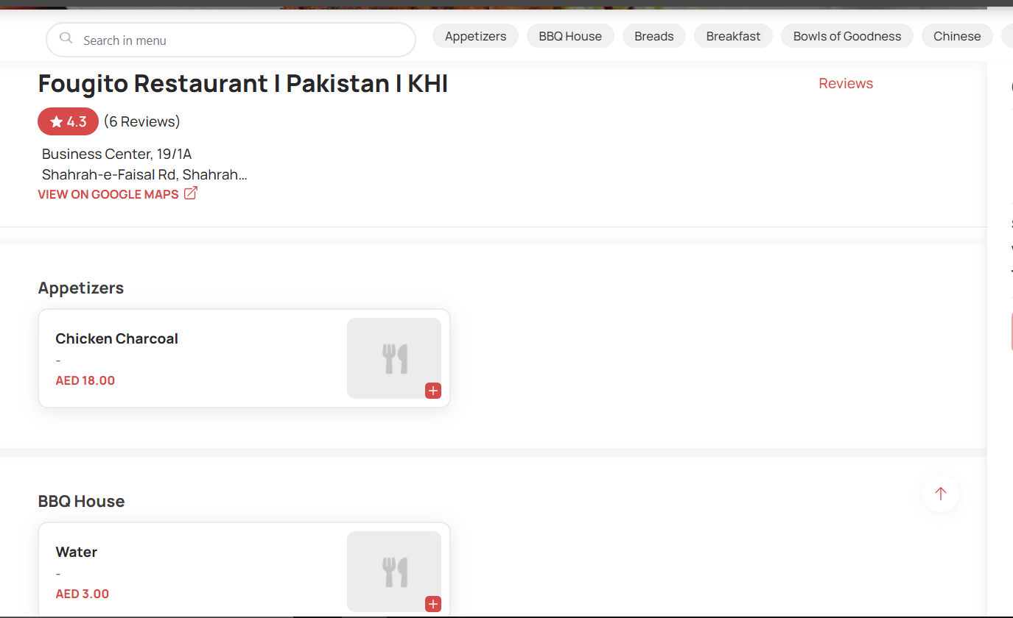

* **Select Items**:
  + **Add to Cart**:
    - Users select items from the menu.
    - Users can add special instructions from **Order Summary** too.
    - Users can add or remove items from their cart as needed.

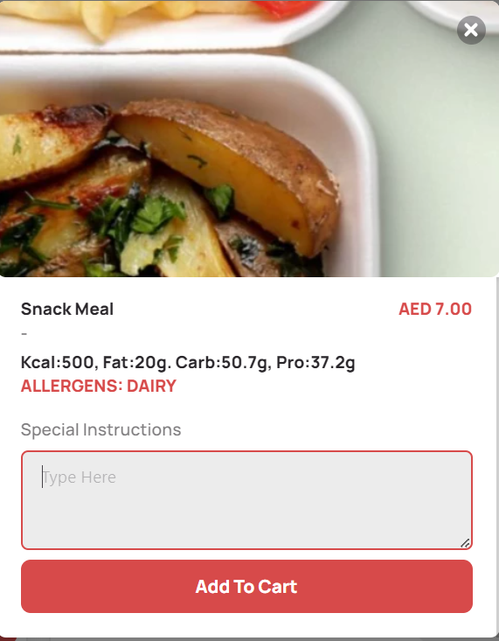

* **Order Summary**:
  + **Payment Options**:
    - Users choose between two payment methods:
      * **Pay with Cash**: Pay when picking up the order.
      * **Pay Online**: Complete the payment through an online gateway.
      * Also each item has a **Special Instructions** box where users can customize their order with specific requests or modifications.

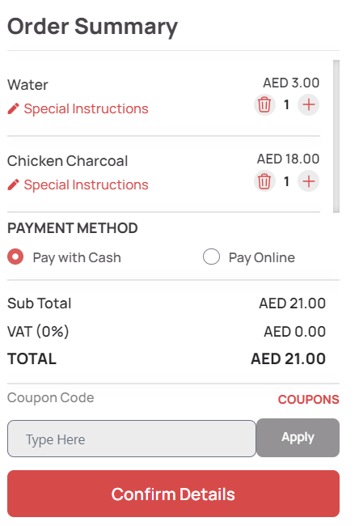

* + **Cost Details**:
    - **Sub Total**: Total cost before taxes and discounts.
    - **VAT (fixed from restaurant’s admin portal)**: Tax amount (if applicable).
    - **Total**: Final amount to be paid.
    - **Coupon Code**: Field to enter any discount codes.



* **Confirm Order**:
  + **Enter Confirmation Information**:
    - Users provide their personal details:
      * **Name:** Users will add his name
      * **Phone Number:** Users will enter the phone number. After submission, they will receive an OTP on that number. The system will only accept the phone number once the correct OTP is provided, ensuring the number is verified.
      * **Email Address:** This is an optional field
  + Users can choose if cutlery is needed
  + Also users can add label to their order for the convenience
  + Users confirm all order details and proceed with the confirmation.

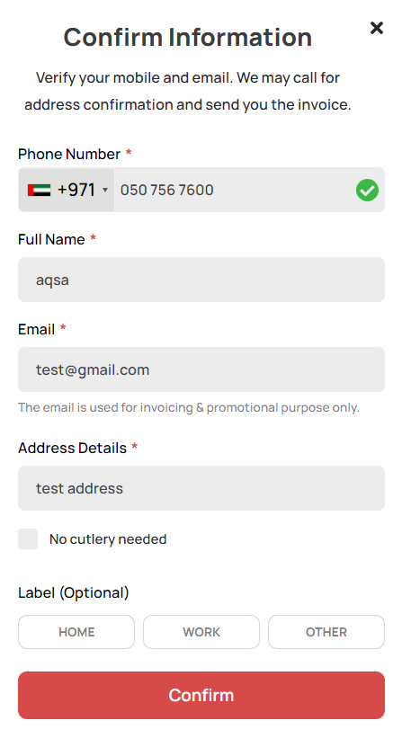

* **Pay Online Option:**

When users select the "Pay Online" option, they are directed to the Card Details page. On this page, they need to enter their wallet details to complete the payment.

Additionally, on the Card Details page, users have the option to switch to "Pay with Cash" if they prefer not to pay online. This option allows them to change their payment method before finalizing the order.

* **Order Status**:
  + Users review the final order details, including:
    - Order Status
    - Order Summary
    - Payment Details

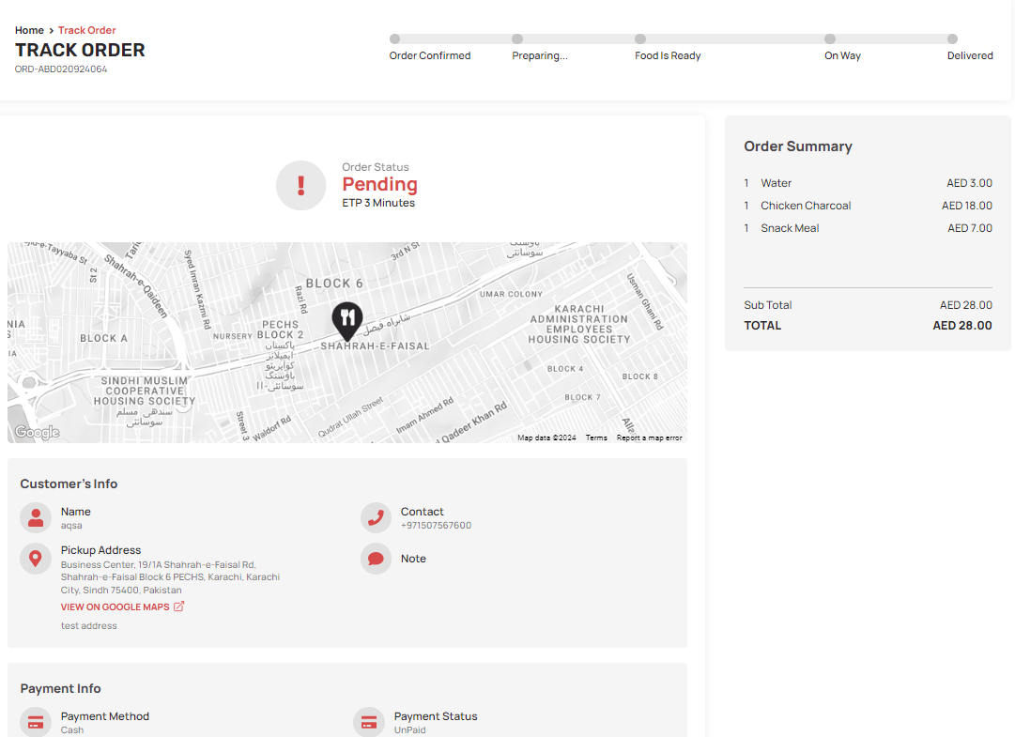

#### **4. Switch to Delivery**

* **Delivery Location**:
  + **Enter Delivery Address**:
    - Users input their delivery address to find the nearest branch.

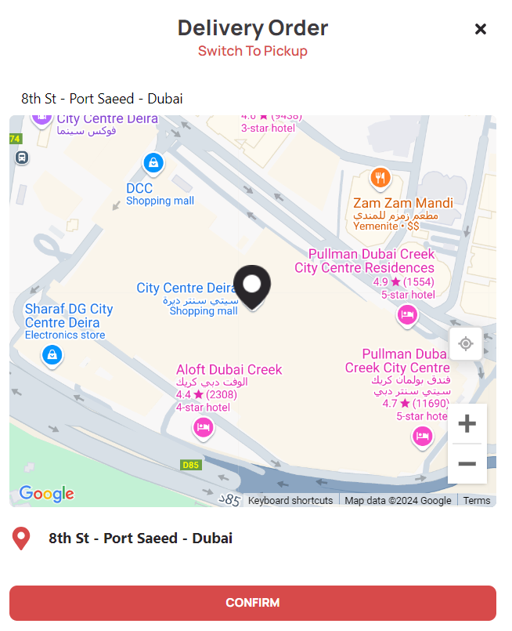

* **Nearest Branch Menu**:
  + The website displays the menu for the branch closest to the provided delivery address.
  + Users can select items in the same manner as for pickup and follow the same ordering process as described for pickup.
  + For online delivery orders, users can also schedule their deliveries by selecting a preferred date and time. This allows them to place an order for a future date and time that suits their convenience.

#### **5. Trending Categories**

* **Category Selection**:
  + **Click on a Category**:
    - Users select a category from the "Trending Categories" section on the home page.

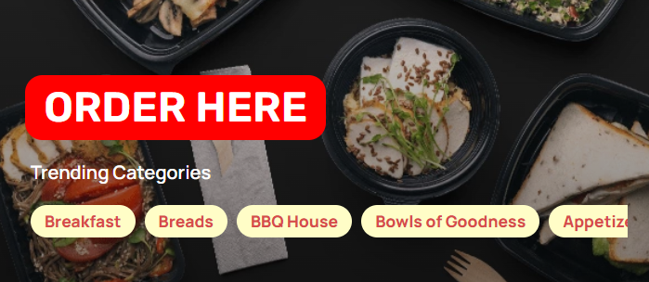

* **Location Entry**:
  + **Add Location**:
    - Users provide their location or can switch to pickup to determine the nearest branch.
* **Category Menu**:
  + The menu of the nearest branch offering items from the selected category is displayed.
  + Users select items and follow the same ordering process as described for pickup and delivery.

**Meal Plan Flow**

* **Navigating to Meal Plan**:
  + On the home page, users click on the **"**Meal Plan" option to begin exploring meal planning options.

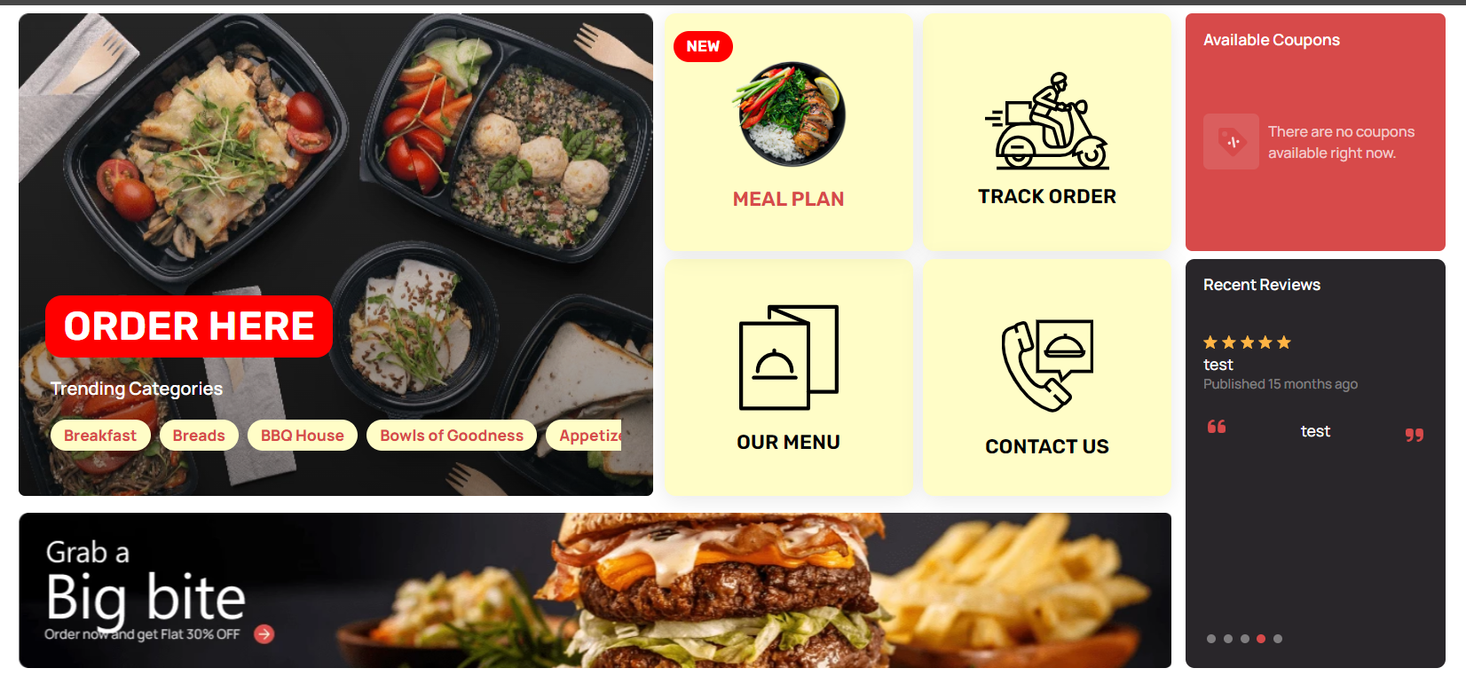

* **Entering Location**:
  + Users are prompted to enter their location to find meal plans available at the nearest branch.

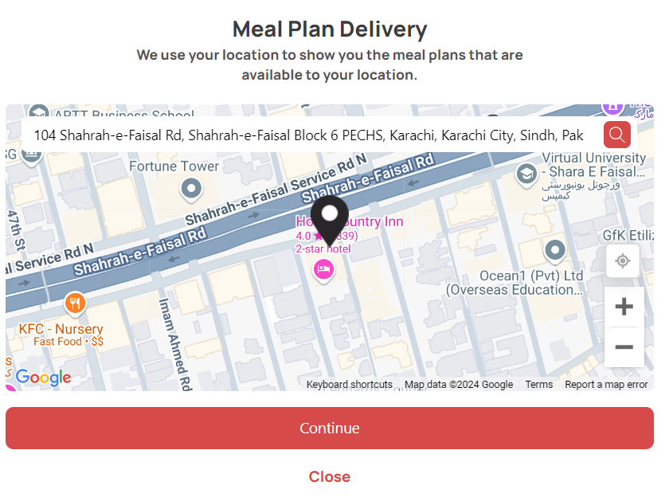

* **Viewing Weekly Meal Plan**:
  + Once the location is entered, users are presented with a complete weekly meal plan from the nearest branch.
  + The weekly plan covers meals for every day of the week, from Monday through Sunday.

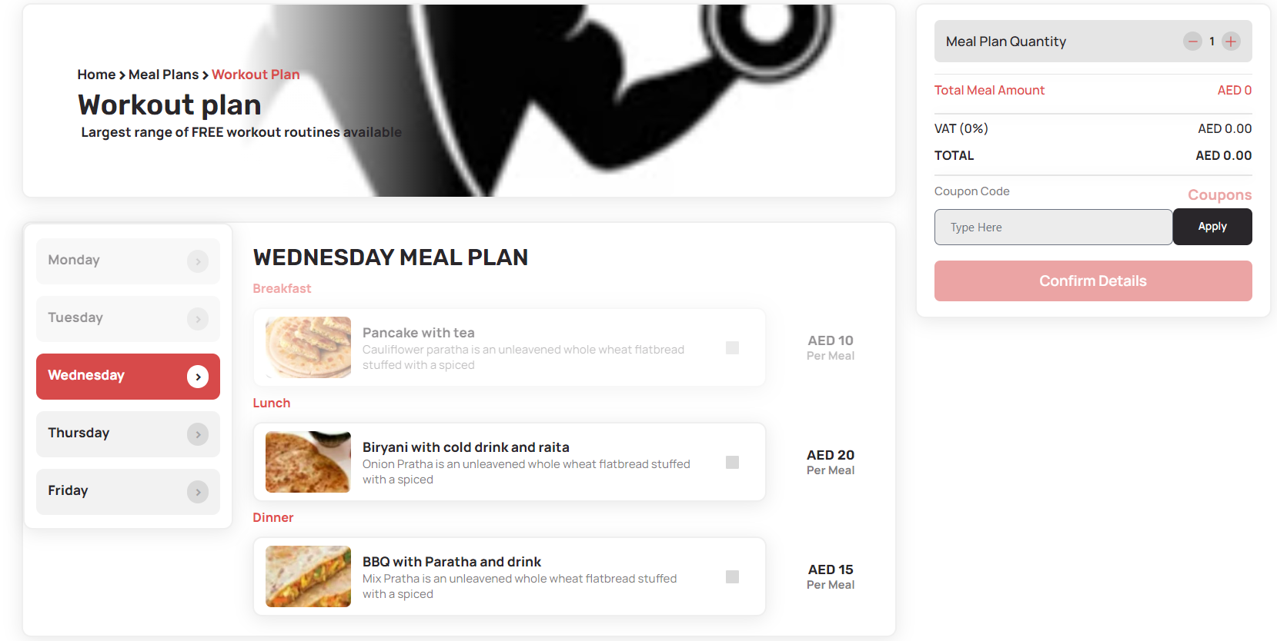

* **Selecting Days**:
  + Users can select specific days for which they want to order meal plans. They are given the option to choose any day of the upcoming week, starting from the current day. For instance, if today is Tuesday, users can select meal plans for Wednesday through Sunday.
* **Selecting Meals**:
  + Users can choose from breakfast, lunch, and dinner options available for each selected day. Each meal type is listed with its available choices for the days selected.

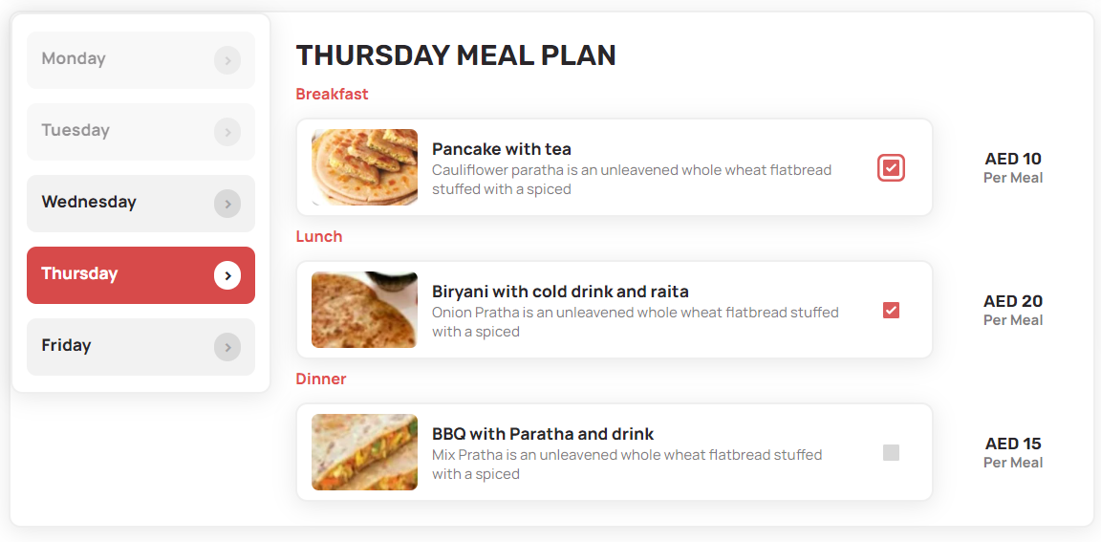

* **Choosing Slots**:
  + For each meal type, users can select preferred time slots. Multiple time slots are available for each meal, such as different breakfast slots, to accommodate various schedules.

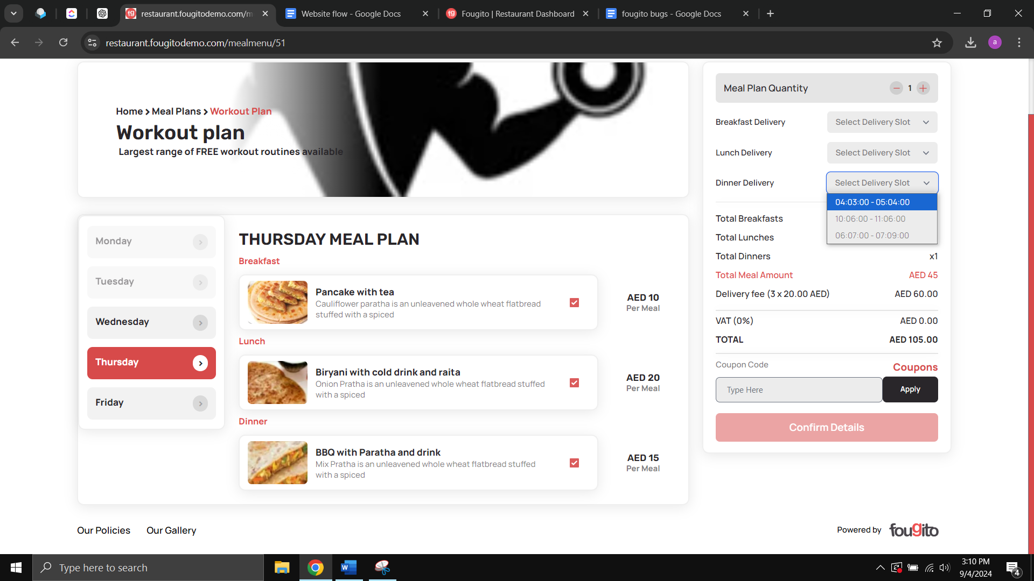

* **Customizing the Order**:
  + Users can specify the quantity of each meal type and day. They have the option to order more than one serving if needed.



* **Viewing the Order Summary**:
  + The order summary displays detailed cost information, including the total price with and without tax.
  + Users have the option to enter a coupon code for discounts, if applicable.



* **Confirming the Order**:
  + Users enter their personal information, including their name, phone number, and email address, to complete the order.
  + After entering their details, users confirm their meal plan order by clicking the "Confirm Order" button.

**Track Order Flow**

To track an order, users begin by selecting the "Track Order" option on the website. On this page, they will be prompted to enter their Order ID and Phone Number. After inputting these details, users click the "Proceed" button.

Once the "Proceed" button is clicked, users are directed to the Track Order page. The type of order—whether a meal plan or a standard order—determines the information displayed

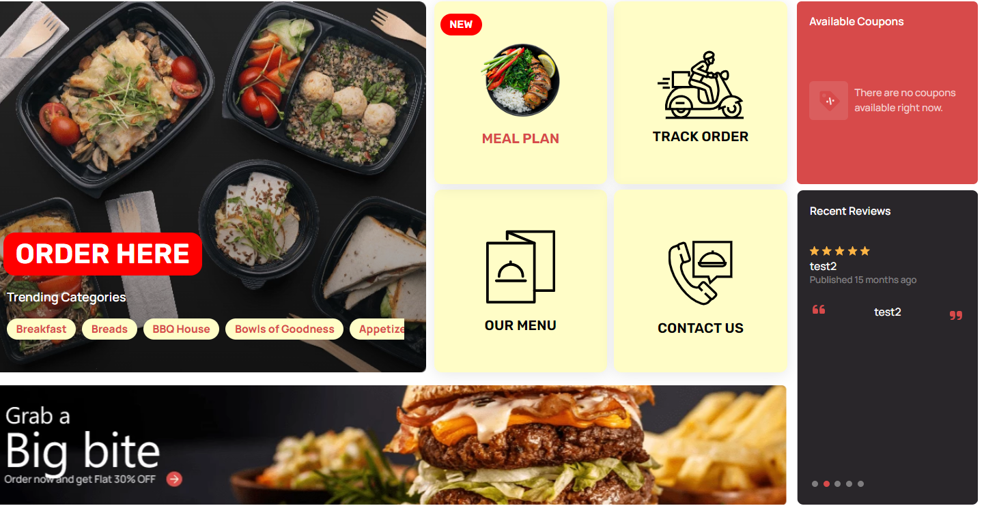

**For Meal Plan Orders:**

* Users can view the status of each meal for every selected day of their meal plan. This includes seeing which meals are scheduled for each day and their delivery status.
* The page features a Customer Info Section, where users can see their personal details and the scheduled meal delivery times.
* The Order Details Section provides a comprehensive breakdown of the order. This includes:
  + The total number of breakfasts, lunches, and dinners ordered.
  + The total meal amount before taxes.
  + Delivery fees, if applicable.
  + The subtotal of the order and the final total amount.
* Users can also view Payment Information related to their meal plan.

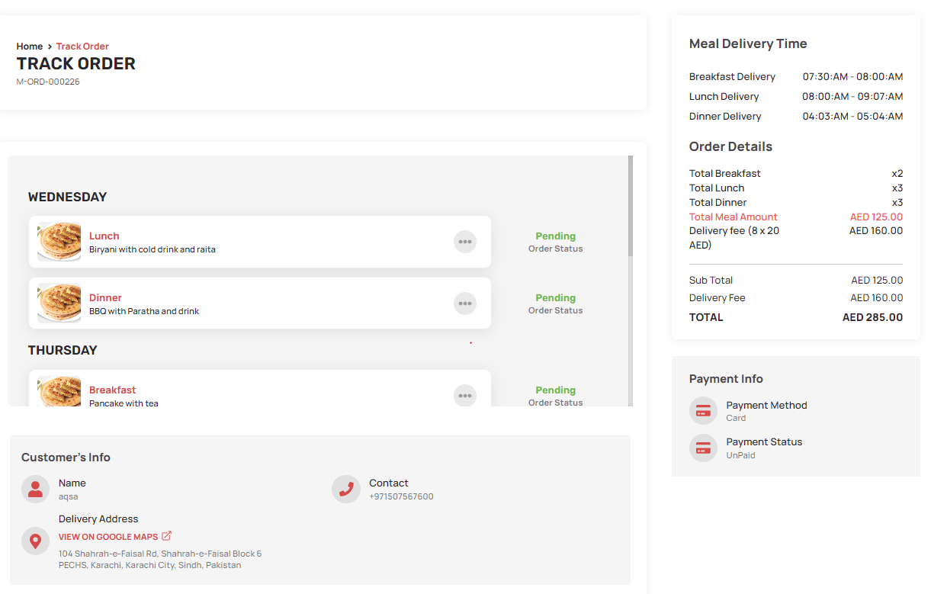

**For Standard Orders:**

* Users will see detailed information about their specific order, including its current status and estimated delivery time.
* A map is included to allow users to track the real-time location of their delivery.
* The page also displays an Order Summary, which includes details about the items ordered and their costs.
* Users can view their Customer Info and Payment Information for the order.
* Additionally, Rider’s Info is provided, giving details about the delivery rider, such as their contact information and name.

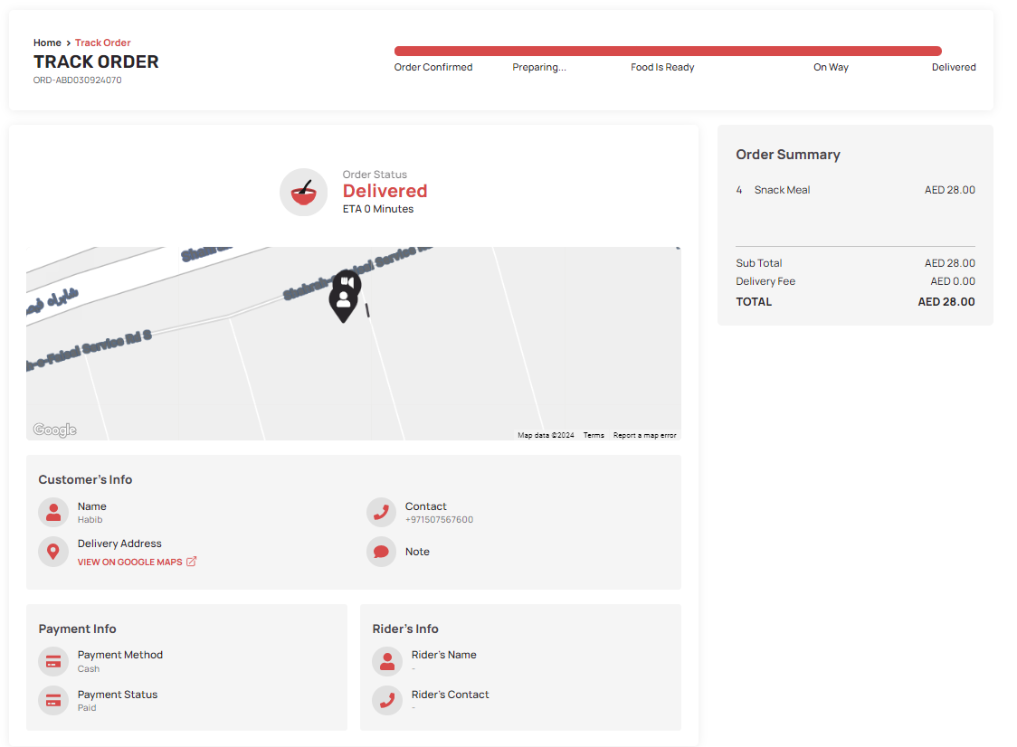

**Our Menu Flow**

To explore the menu options, start by selecting the **"Our Menu"** option from the home page or navigation menu.



On the Our Menu page, users are presented with a list of all restaurant branches. Each branch listing includes a See Menu button.

When users click on the **"See Menu"** button for a particular branch, they are taken to a detailed view of the menu specific to that branch. This view includes:

* **Complete Menu**:
  + A comprehensive listing of all available dishes and beverages at that branch. The menu is categorized to make navigation easier (e.g., appetizers, main courses, desserts, drinks).
* **Reviews and Ratings**:
  + Users can view customer reviews and ratings for those branches.

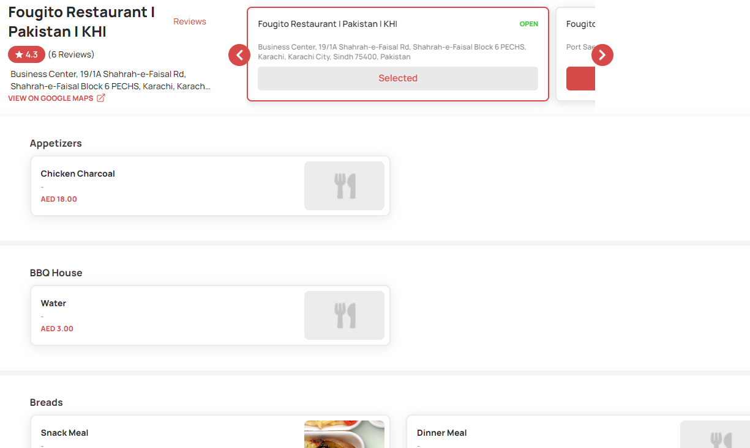

**Available Coupons Flow**

To access and view coupon codes, select the **"Available Coupons"** option from the home page. Here users are presented with a detailed list of all current coupon codes that can be applied to their orders.



**List of Coupons**:

* + **Coupon Code**: Each coupon entry displays the unique code that users need to enter during checkout to redeem the discount.
  + **Coupon Name**: The name or brief description of the coupon, indicating the type of offer (e.g., "10% Off on Orders Over AED 50").
  + **Expiry Date**: The date until which the coupon is valid. This ensures users can use the coupon before it expires.
  + **Minimum Order Requirement**: Any minimum purchase amount required to apply the coupon (e.g., "Valid on orders of AED 30 or more"). This helps users understand the conditions under which the coupon can be used.

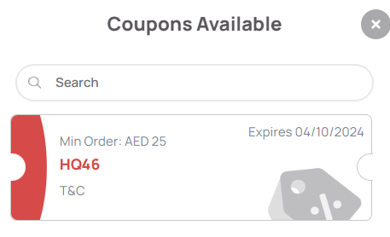

**Contact Us Flow**

When users click on the **"Contact Us"** button, they are directed to the Contact Us page. This page provides comprehensive information to facilitate communication between users and the Fougito Restaurant team.



On the **Contact Us** page, users will find:

* **Contact Details**:
  + A section displaying all relevant contact information for Fougito Restaurant. This includes:
    - **Phone Numbers**: Contact numbers for general inquiries and support.
    - **Email Addresses**: Email addresses for different types of inquiries (e.g., customer service, feedback, reservations).
* **All Locations**:
  + A list of all restaurant branches with their addresses. This section helps users find the nearest branch or get in touch with a specific location. Each branch listing includes:
    - **Branch Address**: Full address of each restaurant location.
    - **Phone Number**: Contact number specific to each branch, if available.
* **Contact Form**:
  + A form that users can fill out to send a direct message to the super admin of Fougito Restaurant. The form typically includes fields for:
    - **Name**: The user’s full name.
    - **Email Address**: The user’s email address for correspondence.
    - **Phone number**: A field to specify the subject of the message.
    - **Message**: A text area where users can write their message or inquiry.
  + After filling out the form, users click the "Send" button to submit their message.

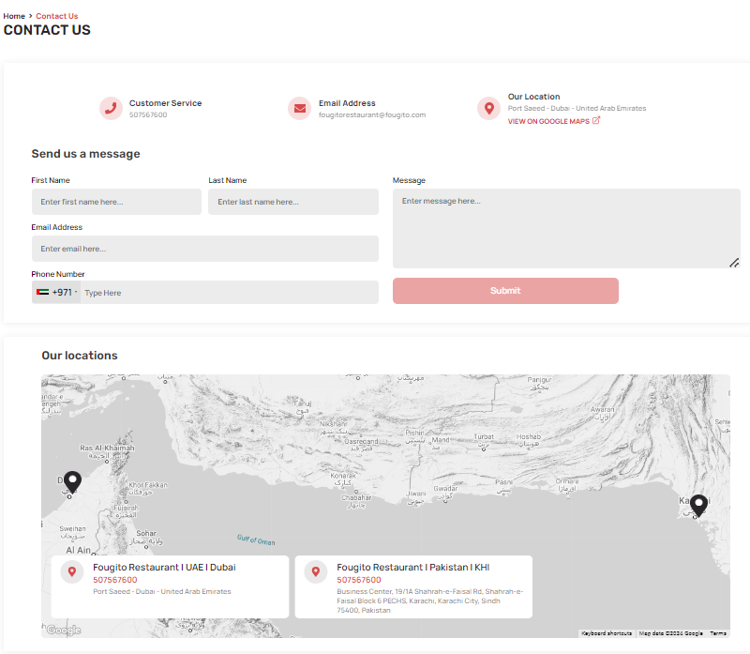

**Recent Reviews Section**

On the home page, the **Recent Reviews** section features customer feedback. It displays:

* **Customer Name**: The name of the reviewer.
* **Date**: When the review was posted.
* **Review Text**: A brief comment on their experience.
* **Rating**: A star rating or numeric score given by the customer.



**Table Reservation Section**

On the home page, the **Table Reservation** section allows users to book a table in advance. To make a reservation, users need to provide the following details:

* **Branch Name**: Select the restaurant branch where they wish to reserve a table.
* **Reservation Date**: Choose the date for the reservation.
* **Reservation Time**: Specify the time for the table booking.
* **Number of Guests**: Indicate how many people will be attending.
* **Special Instructions**: Provide any special requests or requirements for the reservation (e.g., seating preferences, dietary needs).
* **Contact Details**: Enter their contact information, including:
  + **Full Name**: The name of the person making the reservation.
  + **Phone Number**: A contact number for any follow-up or confirmation.
  + **Email Address**: An email address for sending reservation details and confirmation.

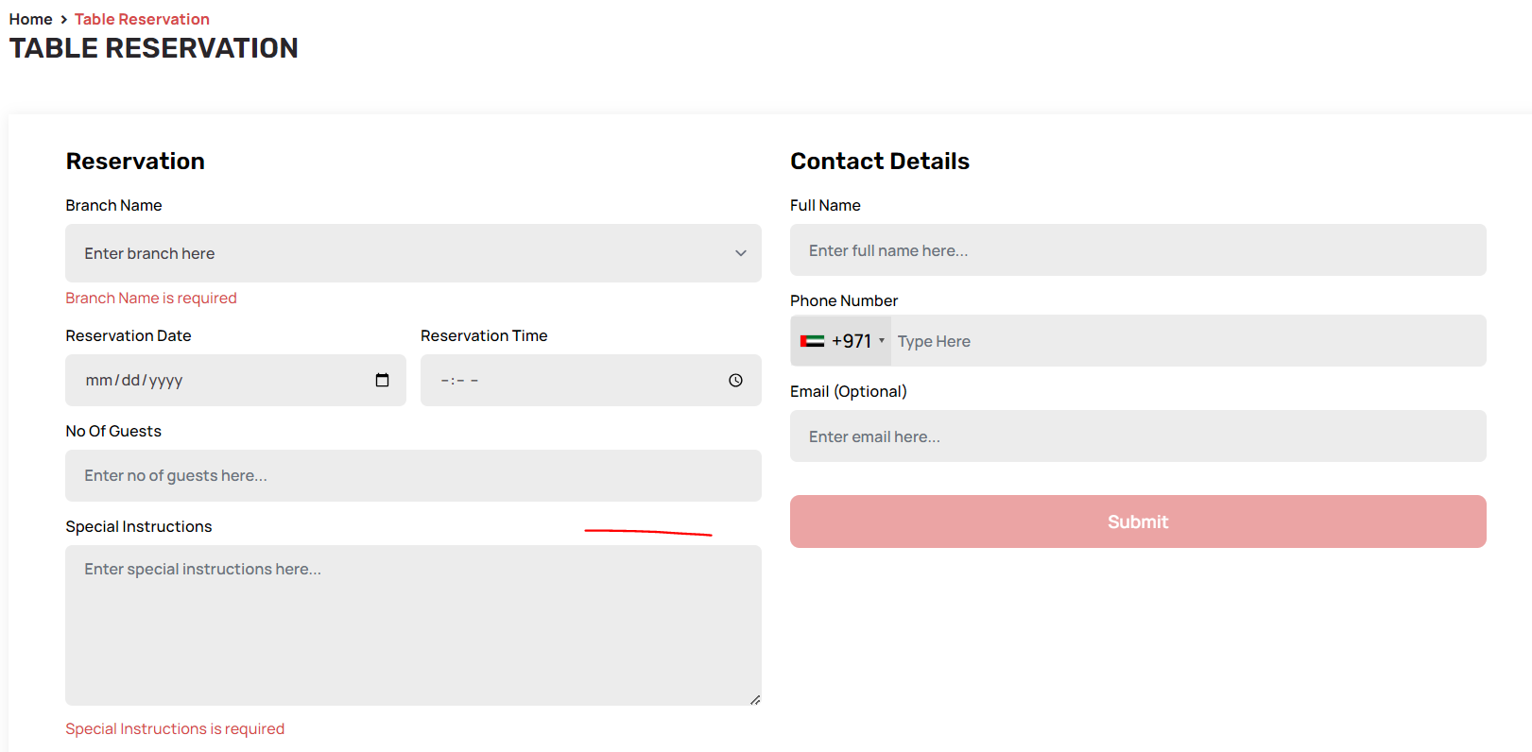

By filling out and submitting this form, users can secure a table at their preferred Fougito Restaurant branch.

**Feedback Section**

The **Feedback** section on the Fougito Restaurant website allows users to provide their opinions and rate their experience. Here’s how it works:

* **Feedback Form**:
  + **Name**: Users enter their full name.
  + **Rating**: Users give a rating
  + **Comments**: Users can write detailed feedback about their experience, including any suggestions or observations.
  + **Submission**: After filling out the form, users submit their feedback.

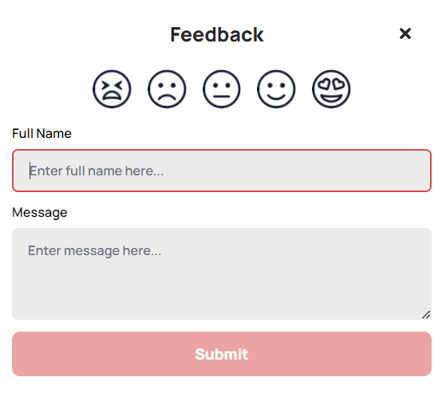

* **Review by Super Admin**:
  + The submitted feedback and ratings are visible to the super admin through the admin portal.

**QR Dine-In Flow**

1. **Placing an Order**:
   * **Scan QR Code**: Users will find a QR code placed on their table. They open Google or another QR code scanning app and scan the code.

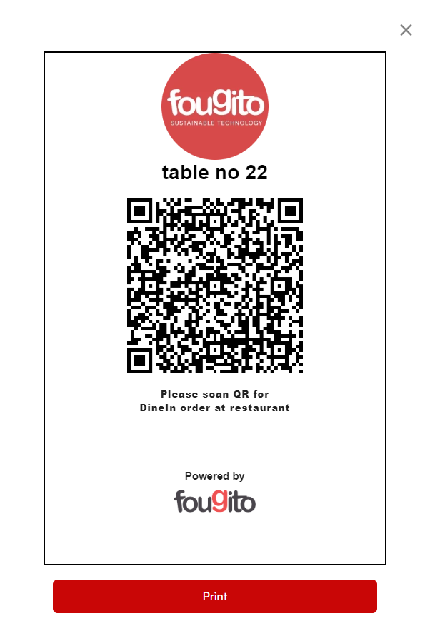

* + **Redirect to Menu**:
    - **Location Services**: If the user's phone location is off, they will be prompted to enable location services and a **"Visit Website"** button.

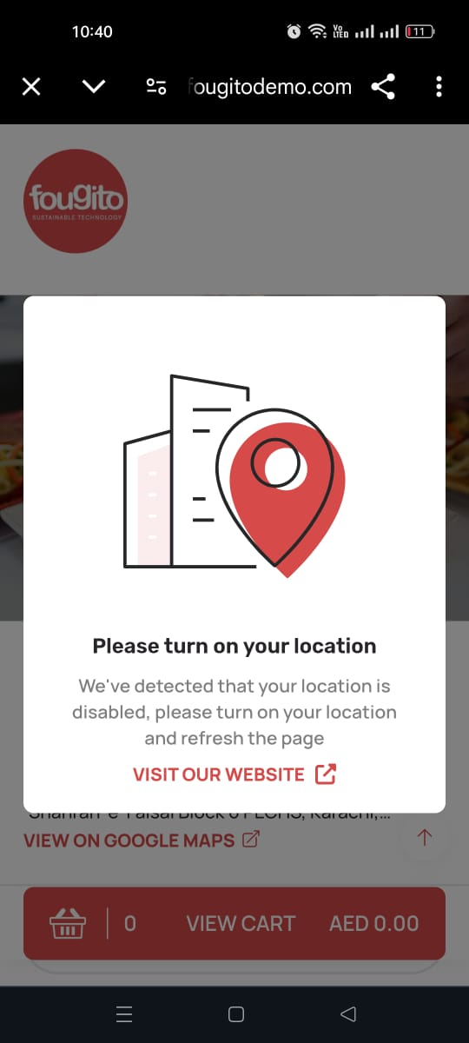

* + - **Location Enabled**: Once location services are enabled and the code is scanned again, the system checks if the user is within the restaurant’s service area.
      * **Within Diameter**: If the user is within the area of a branch, the menu for the nearest branch will appear on their screen.

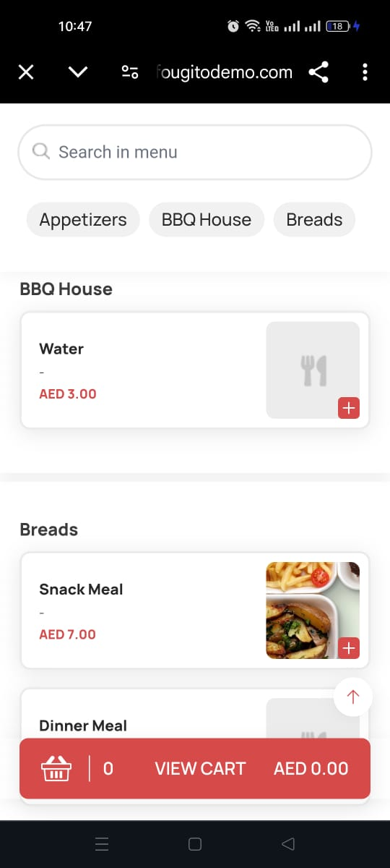

* + - * **Out of Diameter**: If the user is outside the service area, they will receive a prompt indicating they are out of the restaurant’s service area.

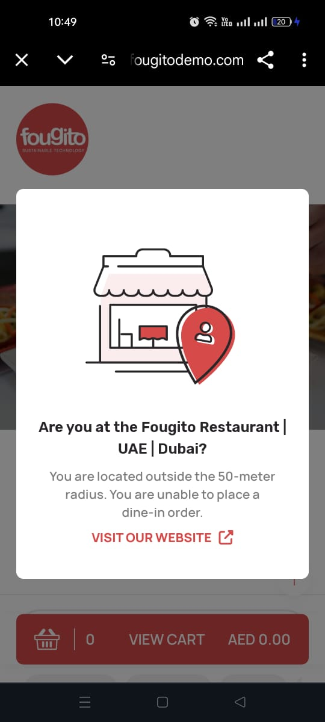

1. **Order Selection**:
   * **Browse Menu**: Users view the menu of the nearest branch, organized into categories such as appetizers, main courses, and desserts.
   * **Add Items to Cart**: Users select items and add them to their cart.

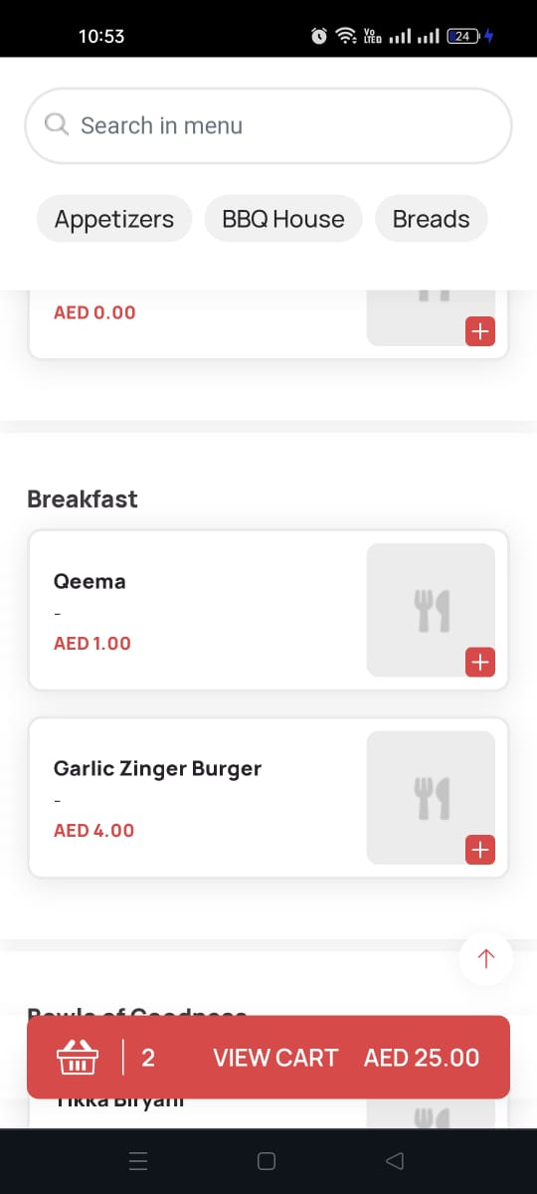

* + - **Special Instructions**: Users can provide special instructions or customization notes for each item.

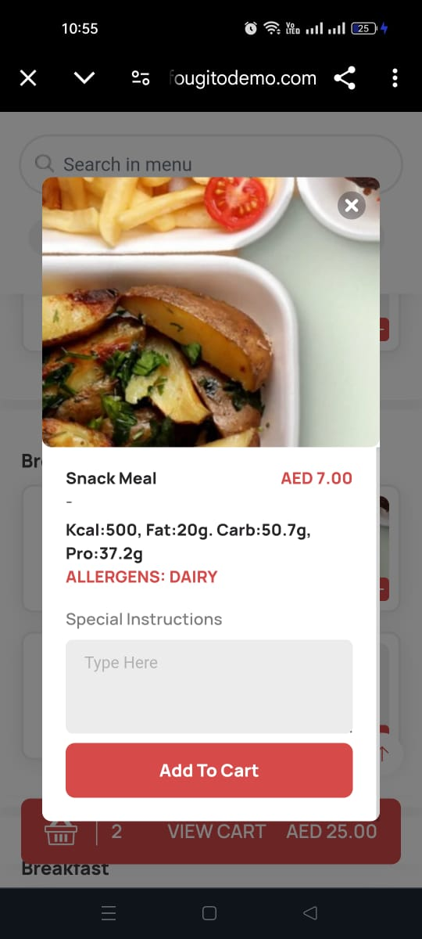

* + **Review Cart**: Users can view their cart, adjust quantities, or remove items.
  + **Order Summary**:
    - **Order details:** items and their quantities
    - **Sub Total**: The cost of items before taxes.
    - **VAT (fixed from restaurant’s admin portal)**: Tax details.
    - **Total**: The final amount to be paid.

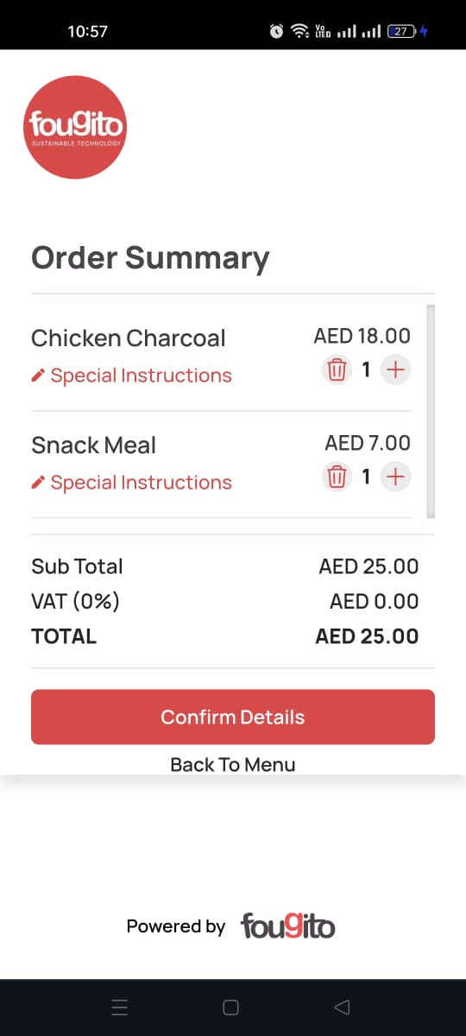

1. **Confirming Order**:
   * **Enter Details**: Users provide the following information:
     + **Full Name**: Their name.
     + **Phone Number**: Their phone number, which will be verified with an OTP.
   * **Verify Phone Number**: After entering the phone number, users will receive an OTP for verification. The number is accepted only after the correct OTP is entered.
   * **Confirm Order**: Users review all details and confirm their order.

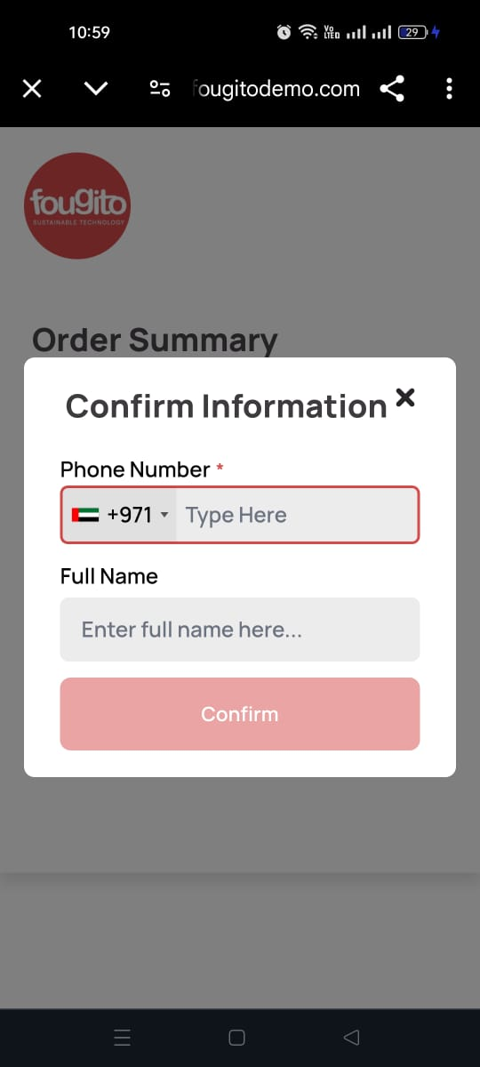

1. **Order Confirmation**:
   * **Confirmation Prompt**: After submitting the order, users receive a prompt confirming that their order has been confirmed, with an option to visit the website.

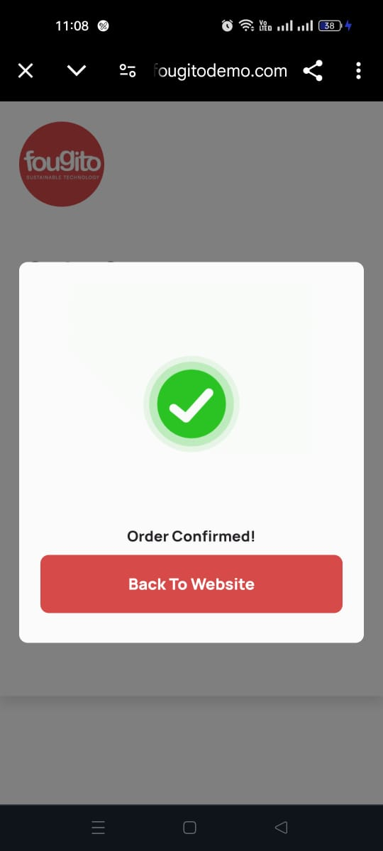

1. **Checking Order Status**:
   * **Scan QR Code**: Users can check the status of their order by scanning the QR code again.
     + **No Response**:
       - If there is no update from the restaurant or the order status hasn’t changed, a prompt will display stating that the food is being prepared. Users can click the **"Close"** button to return to the website.

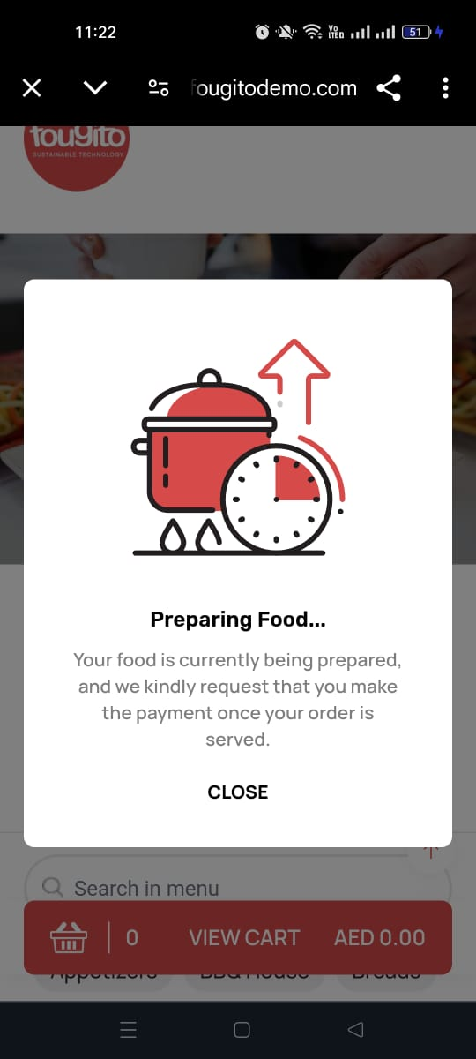

* + - **Order Status Updated**:
      * If the order status has been updated and a waiter has been assigned, users will see a prompt asking if they have finished their meal.

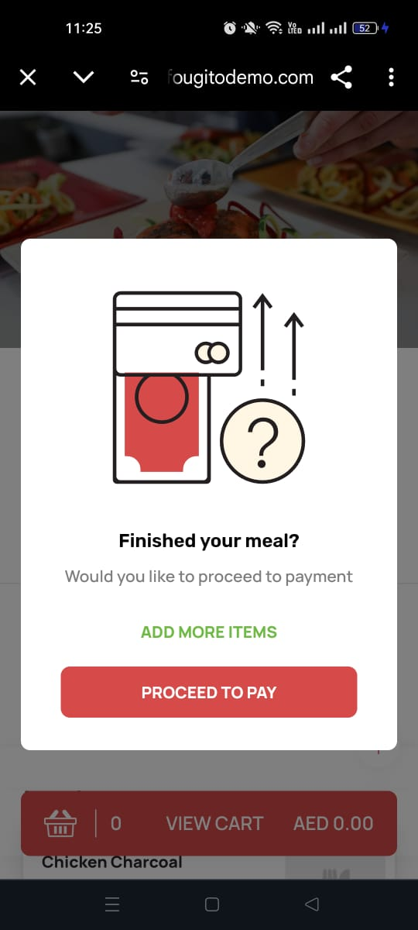

* + - * **Options**:
        + **Add More Items**: Clicking this option will redirect users to the menu, allowing them to order additional items.
        + **Proceed to Pay**: Clicking this option will take users to the order receipt page.

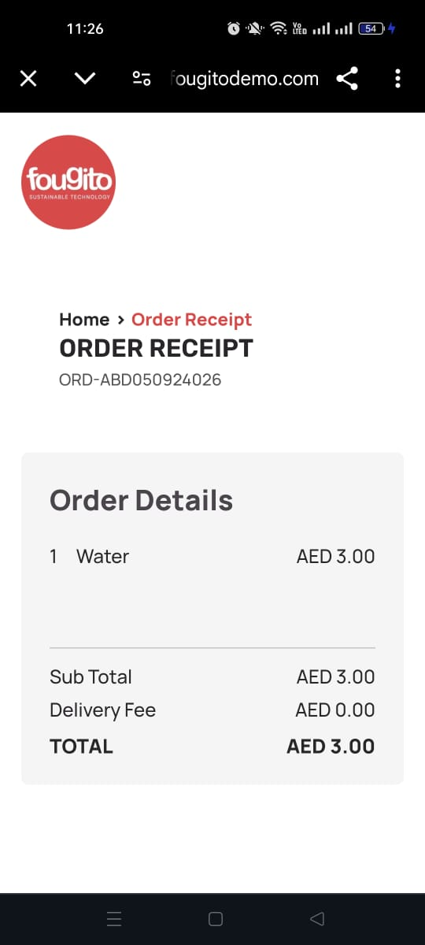

1. **Payment and Feedback**:
   * **Payment**:
     + **Card Details**: Users enter their credit or debit card information.
     + **Rating Page**: After entering card details and completing payment, users are navigated to a review page where they can provide feedback or a rating.

**Track Order via Website**:

* **Track Order Page**: Users can also track their dine-in order from the Track Order section on the website.
  + **Enter Order ID**: Users input their order ID and phone number.
  + **View Status**: The website displays the status of the order, including details such as preparation status and estimated completion time.

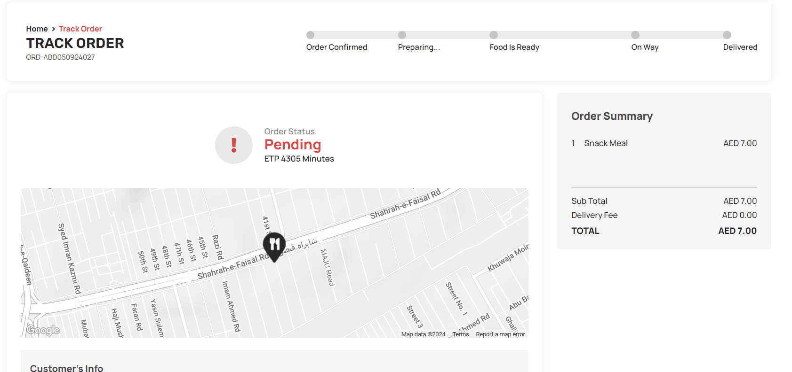

**QR Room Flow**

1. **Placing an Order**:
   * **Scan QR Code**: Users will find a QR code in their hotel room, which is placed on a menu card or other visible location. They open Google or another QR code scanning app and scan the code.

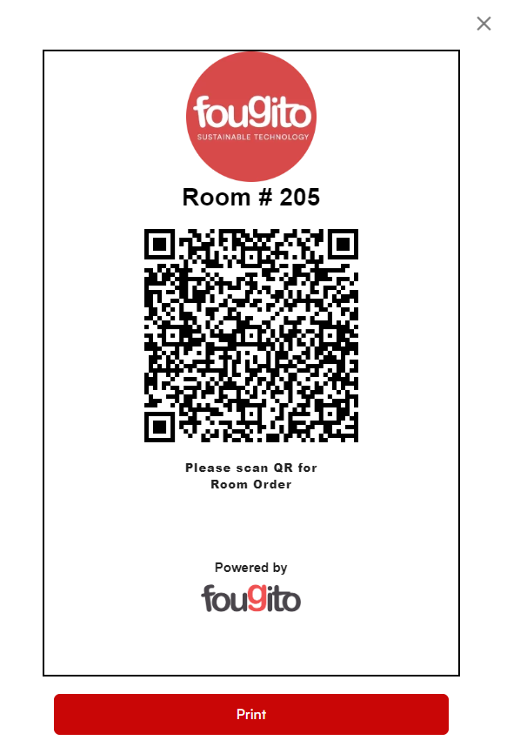

* + **Redirect to Menu**:
    - **Location Services**: If the user's phone location is off, they will be prompted to enable location services and click a **"Visit Website"** button.



* + - **Location Enabled**: Once location services are enabled and the code is scanned again, the system checks if the user is within the hotel’s service area.
      * **Within Diameter**: If the user is within the area of the hotel, the menu for the hotel’s restaurant will appear on their screen.



* + - * **Out of Diameter**: If the user is outside the service area, they will receive a prompt indicating they are out of the restaurant’s service area.

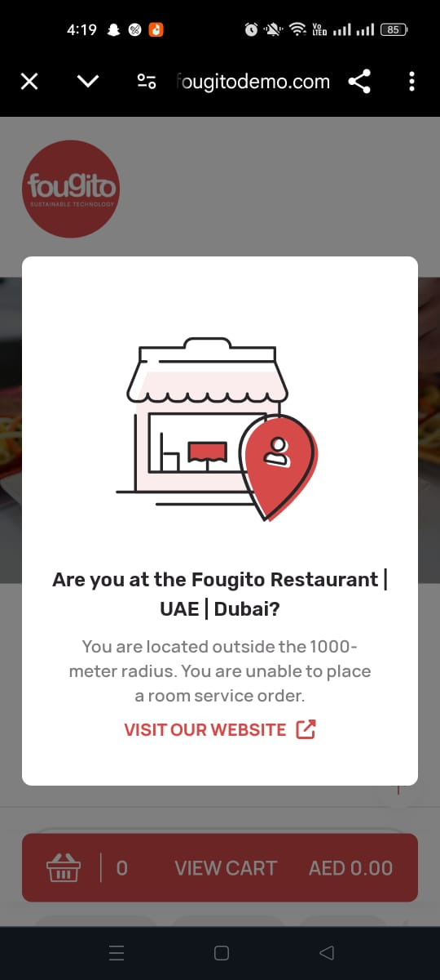

1. **Order Selection**:
   * **Browse Menu**: Users view the menu of the hotel’s restaurant, organized into categories such as appetizers, main courses, and desserts.
   * **Add Items to Cart**: Users select items and add them to their cart.



* + - **Special Instructions**: Users can provide special instructions or customization notes for each item.



* + **Review Cart**: Users can view their cart, adjust quantities, or remove items.
  + **Order Summary**:
    - **Sub Total**: The cost of items before taxes.
    - **VAT (fixed from restaurant’s admin portal)**: Tax details.
    - **Total**: The final amount to be paid.

1. **Choose Payment Method**:
   * **Pay with Cash**: Opt for cash payment.
   * **Pay Online**: Opt for online payment and enter card details if selected.

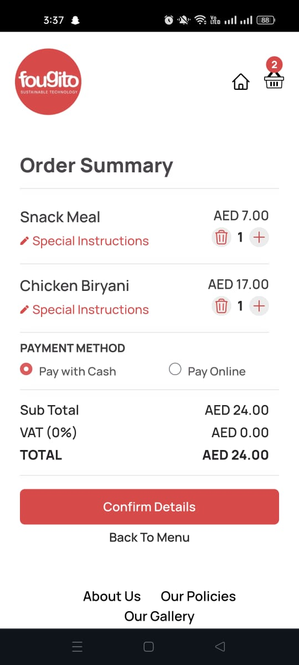

1. **Confirming Order**:
   * **Enter Details**: Users provide the following information:
     + **Full Name**: Their name.
     + **Phone Number**: Their phone number, which will be verified with an OTP.
   * **Verify Phone Number**: After entering the phone number, users will receive an OTP for verification. The number is accepted only after the correct OTP is entered.
2. **Confirm Order**: Users review all details and confirm their order.



1. **Order Confirmation**:
   * **Confirmation Prompt**: After submitting the order, users receive a prompt confirming that their order has been received, with an option to visit the website.

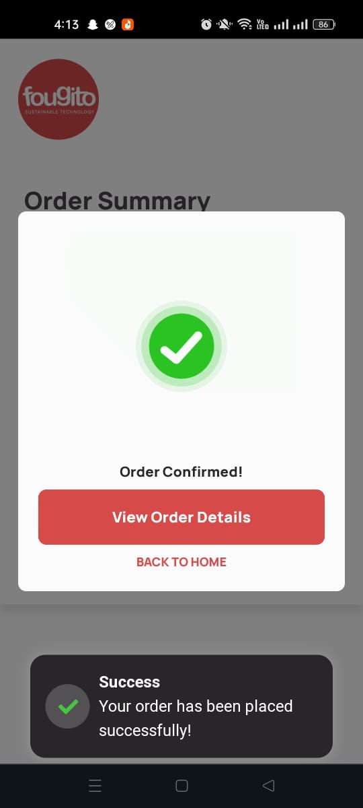

* + - **View Order Details**: Users have the option to view detailed information about their order, including:
      * **Order Status**: The current status of the order.
      * **Customer Info**: Details provided by the user.
      * **Payment Info**: Payment details.
      * **Rider’s Info**: Information about the attendant.
      * **Order Summary**: A summary of the items ordered.

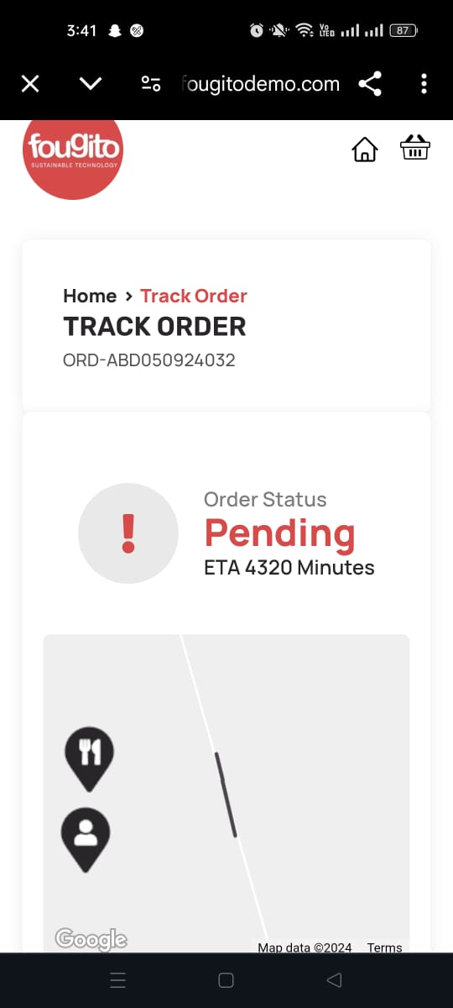 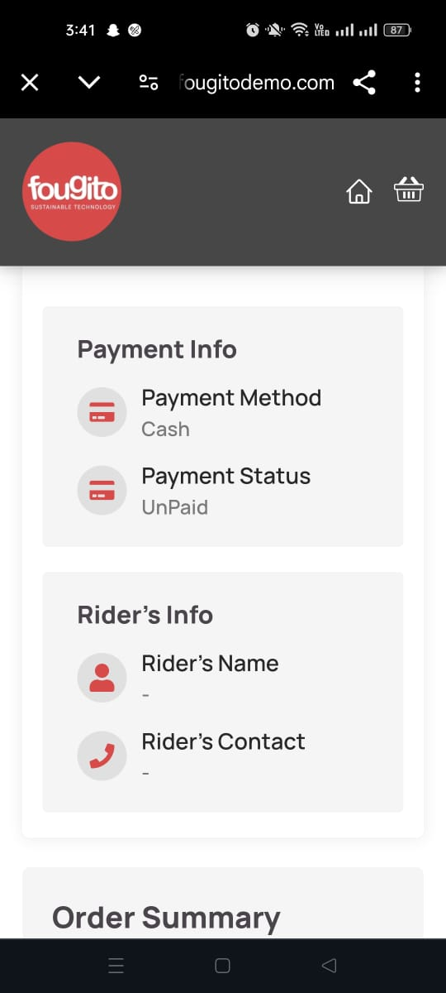 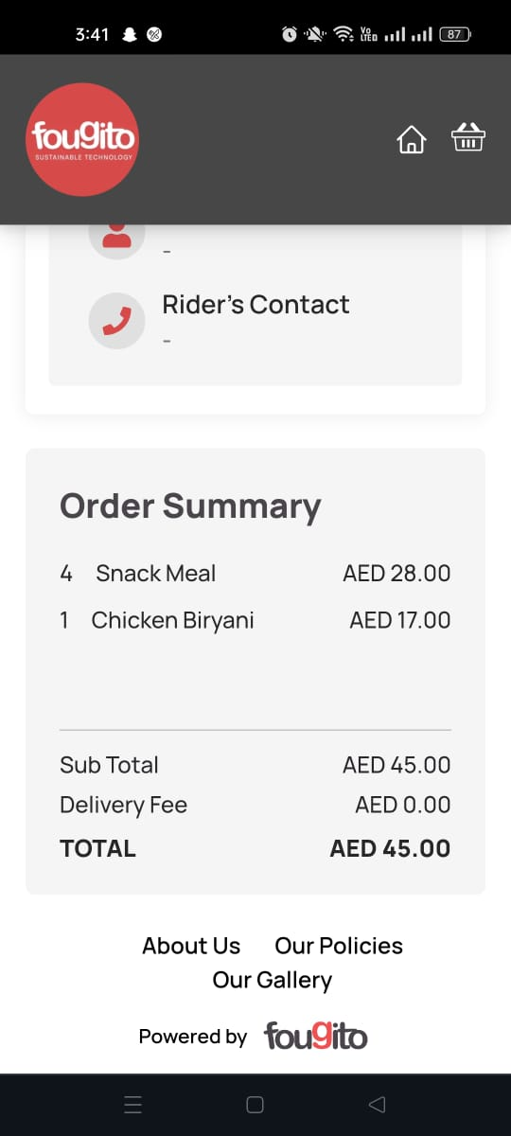

* + **Payment**:
    - **Card Details**: If payment is online then the user will see the pay with wallet option and enter their credit or debit card information.
    - **Switch to Cash**: users have the option to switch to "Pay with Cash" if they prefer not to pay online.

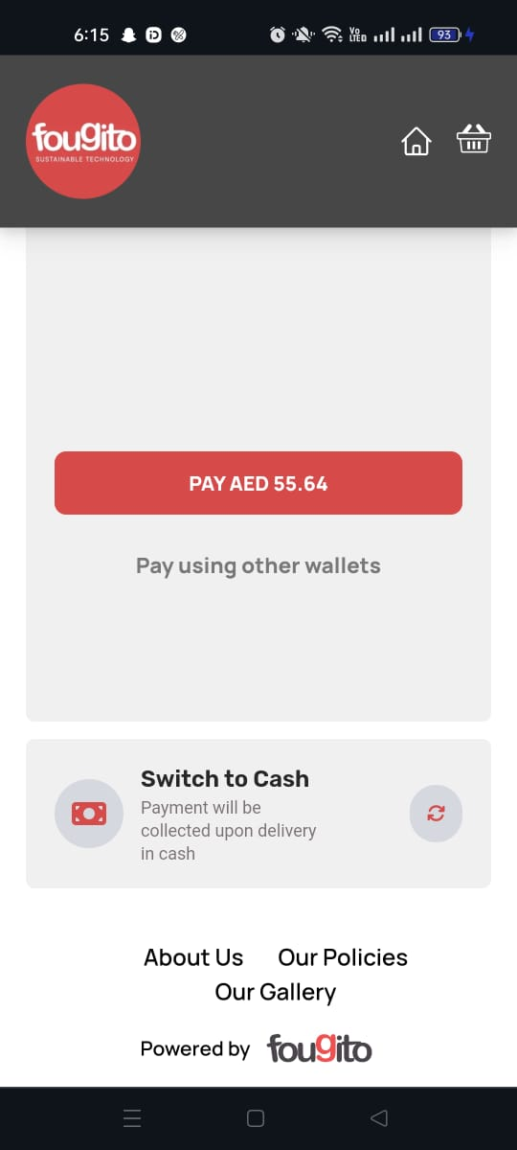

1. **Track Order via Website**:
   * **Track Order Page**: Users can also track their room service order from the Track Order section on the website.
     + **Enter Order ID**: Users input their order ID and phone number.
     + **View Status**: The website displays the status of the order, including details such as preparation status and estimated completion time.



**QR Car Hop Orders**

* **Welcome Screen**:
  1. **Scan QR Code**: Users find a QR code displayed at designated car hop spots or on their car’s dashboard. They open Google or another QR code scanning app and scan the code.

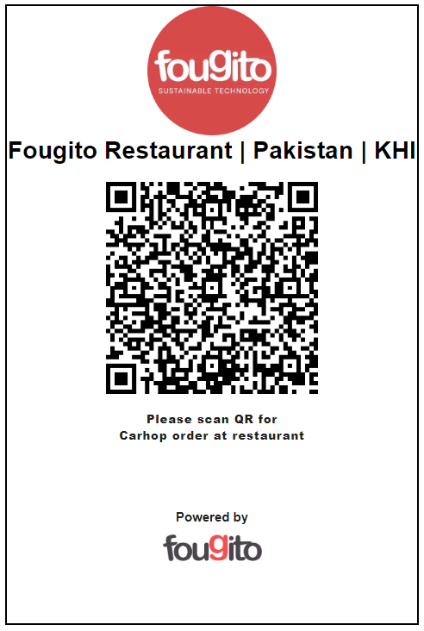

* 1. **Welcome Screen**: Upon scanning the QR code, users are directed to a welcome screen with a field to enter their vehicle licence plate number.

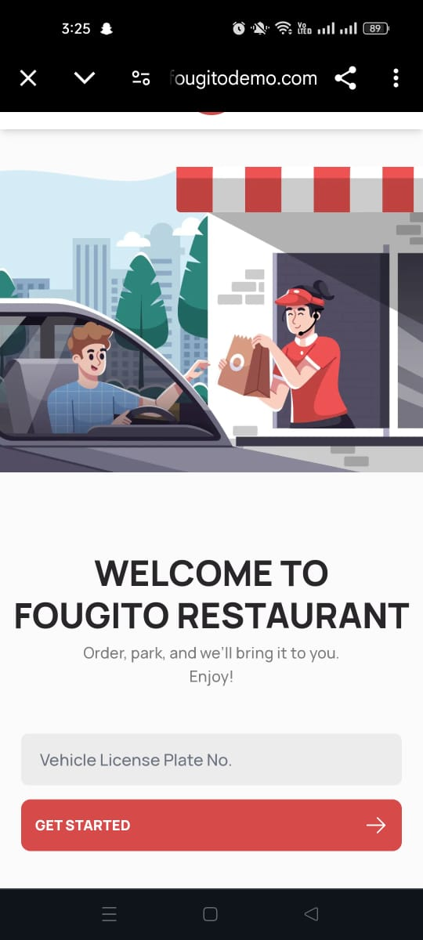

* **Entering Vehicle Information**:
  1. **Licence Plate Number**: Users enter their vehicle’s licence plate number into the provided field.
  2. **Get Started**: After entering the licence plate number, users click the **"Get Started"** button to proceed.

**Menu and Order Placement**:

* **View Menu**: Once the licence plate number is submitted, users are redirected to the menu for the restaurant’s car hop service.
  1. **Location Services**: If the user's phone location is off, they will be prompted to enable location services and click a **"Visit Website"** button.



* 1. **Location Enabled**: Once location services are enabled and the code is scanned again, the system checks if the user is within the restaurant’s designated carhop area.
     + **Within Diameter**: If the user is within the designated carhop area, the menu for the restaurant will appear on their screen.



* + - **Out of Diameter**: If the user is outside the service area, they will receive a prompt indicating they are out of the restaurant’s car hop service area and will be redirected to the website.

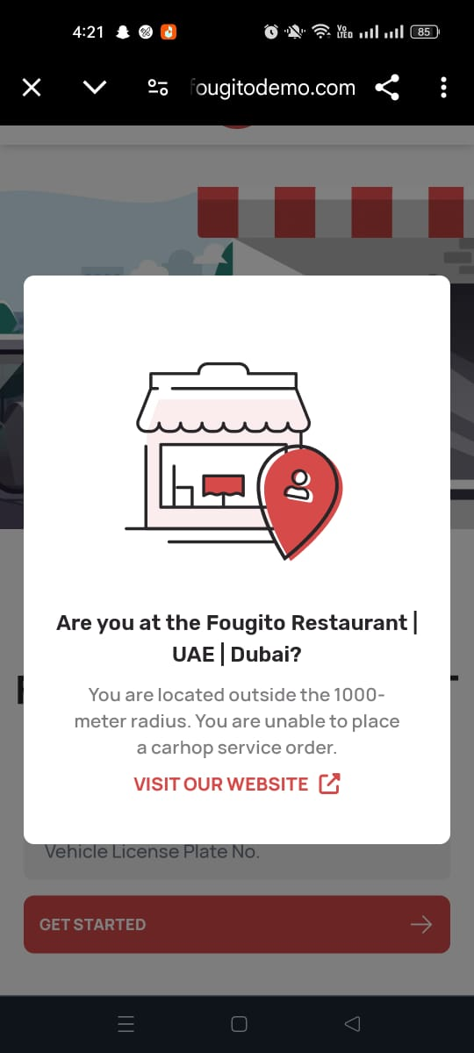

* **Browse Menu**: Users can browse through categories such as appetizers, main courses, and desserts.
  + - **Add Items to Cart**: Users select items and add them to their cart.



* + - * **Special Instructions**: Users can provide special instructions or customization notes for each item.



* + - **Review Cart**: Users can view their cart, adjust quantities, or remove items.
    - **Order Summary**:
      * **Sub Total**: The cost of items before taxes.
      * **VAT (fixed from restaurant’s admin portal)**: Tax details.
      * **Total**: The final amount to be paid.
* **Choose Payment Method**:
  1. **Pay with Cash**: Opt for cash payment.
  2. **Pay Online**: Opt for online payment and enter card details if selected.



* **Confirming Order**:
  1. **Enter Details**: Users provide additional information to finalize their order:
     + **Full Name**: Their name.
     + **Phone Number**: Their phone number, which will be verified with an OTP.
     + **Location of Parked Vehicle**: The location where their vehicle is parked.
     + **Licence Plate Number**: Re-enter the vehicle’s license plate number.
  2. **Verify Phone Number**: After entering the phone number, users will receive an OTP for verification. The number is accepted only after the correct OTP is entered.
  3. **Confirm Order**: Users review all details and confirm their order.

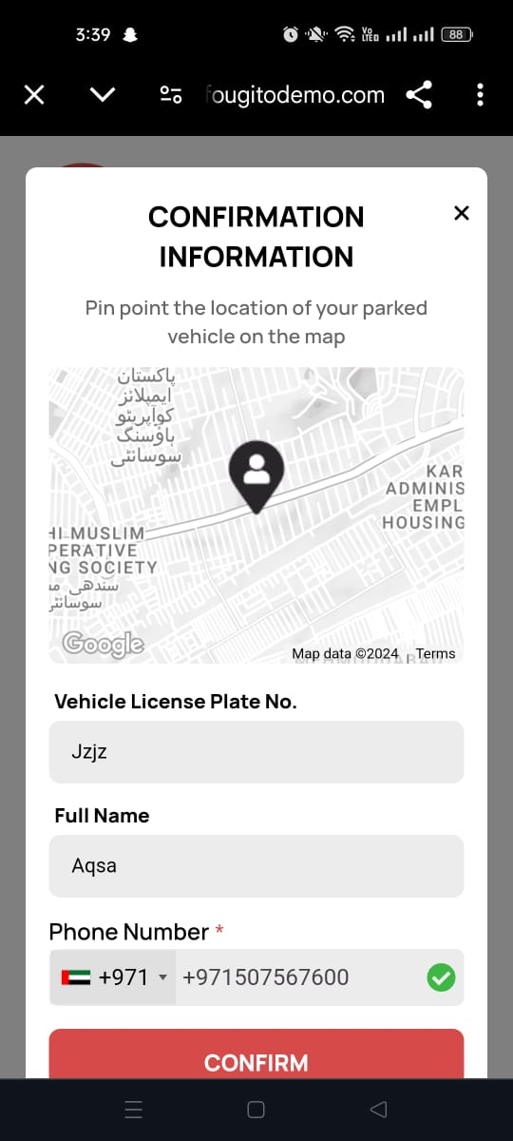

* **Order Confirmation**:
  1. **Confirmation Screen**: After submitting the order, users see an order confirmation screen with a summary of their order.



* + - **View Order Details**: Users have the option to view detailed information about their order, including:
      * **Order Status**: The current status of the order.
      * **Customer Info**: Details provided by the user.
      * **Payment Info**: Payment details.
      * **Rider’s Info**: Information about the car hop attendant.
      * **Order Summary**: A summary of the items ordered.

  

* **Payment**:
  1. **Card Details**: If payment is online then the user will see the pay with wallet option and enter their credit or debit card information.
  2. **Switch to Cash**: users have the option to switch to "Pay with Cash" if they prefer not to pay online.



* **Track Order via Website**:
  + - **Track Order Page**: Users can also track their car hop order from the **Track Order** section on the website.
      * **Enter Order ID**: Users input their order ID and phone number.
      * **View Status**: The website displays the status of the order, including details such as preparation status and estimated delivery time.



### **Fougito Restaurant Ordering Website**

### **QR Dine In Flow**

1. **Placing an Order**:
   * **Scan QR Code**: Users will find a QR code placed on their table. They open Google or another QR code scanning app and scan the code.



* + **Redirect to Menu**:
    - **Location Services**: If the user's phone location is off, they will be prompted to enable location services and a **"Visit Website"** button.



* + - **Location Enabled**: Once location services are enabled and the code is scanned again, the system checks if the user is within the restaurant’s service area.
      * **Within Diameter**: If the user is within the area of a branch, the menu for the nearest branch will appear on their screen.



* + - * **Out of Diameter**: If the user is outside the service area, they will receive a prompt indicating they are out of the restaurant’s service area.



1. **Order Selection**:
   * **Browse Menu**: Users view the menu of the nearest branch, organized into categories such as appetizers, main courses, and desserts.
   * **Add Items to Cart**: Users select items and add them to their cart.



* + - **Special Instructions**: Users can provide special instructions or customization notes for each item.



* + **Review Cart**: Users can view their cart, adjust quantities, or remove items.
  + **Order Summary**:
    - **Order details:** items and their quantities
    - **Sub Total**: The cost of items before taxes.
    - **VAT (fixed from restaurant’s admin portal)**: Tax details.
    - **Total**: The final amount to be paid.



1. **Confirming Order**:
   * **Enter Details**: Users provide the following information:
     + **Full Name**: Their name.
     + **Phone Number**: Their phone number, which will be verified with an OTP.
   * **Verify Phone Number**: After entering the phone number, users will receive an OTP for verification. The number is accepted only after the correct OTP is entered.
   * **Confirm Order**: Users review all details and confirm their order.

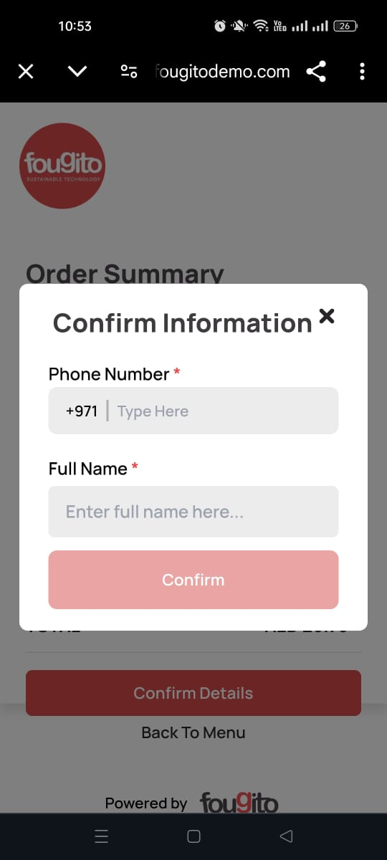

1. **Order Confirmation**:
   * **Confirmation Prompt**: After submitting the order, users receive a prompt confirming that their order has been confirmed.

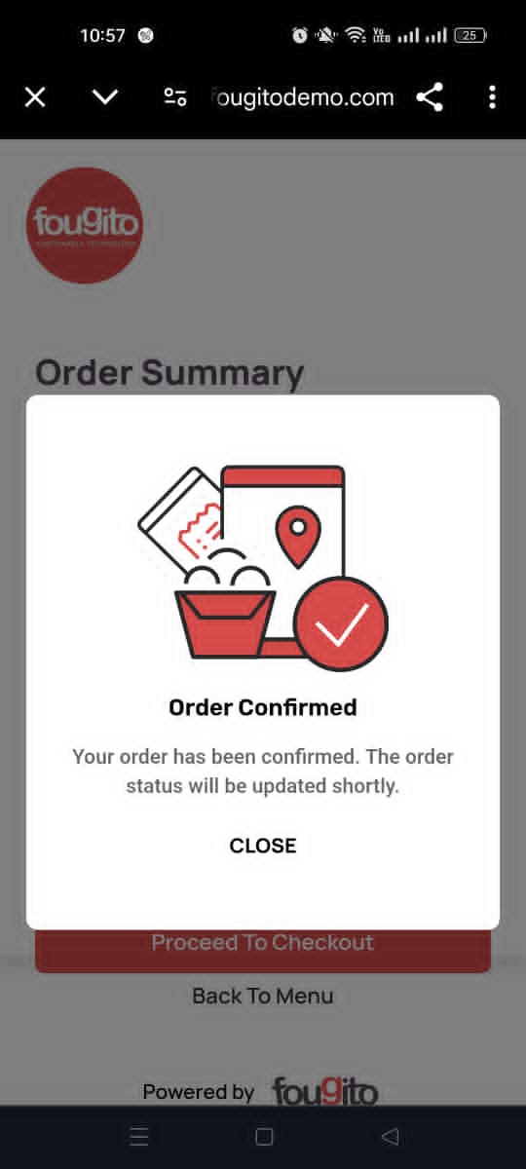

1. **Checking Order Status**:
   * **Scan QR Code**: Users can check the status of their order by scanning the QR code again.
     + **No Response**:
       - If there is no update from the restaurant or the order status hasn’t changed, a prompt will display stating that the food is being prepared. Users can click the **"Close"** button to return to the website.



* + - **Order Status Updated**:
      * If the order status has been updated and a waiter has been assigned, users will see a prompt asking if they have finished their meal.



* + - **Options**:
      * **Add More Items**: Clicking this option will redirect users to the menu, allowing them to order additional items.
      * **Proceed to Pay**: Clicking this option will take users to the order receipt page.

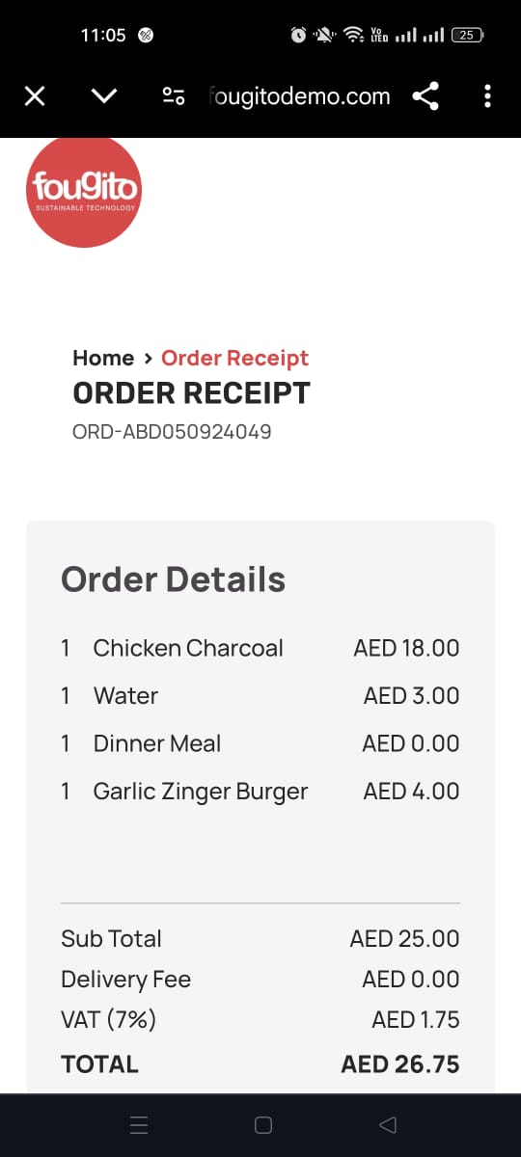 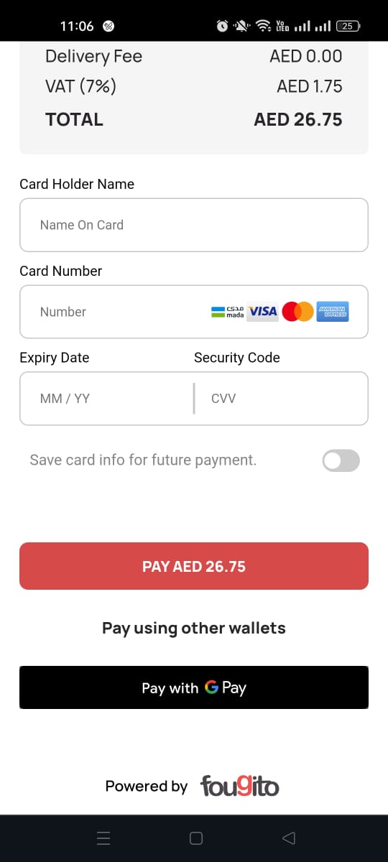

1. **Payment and Feedback**:
   * **Payment**:
     + **Card Details**: Users enter their credit or debit card information with an option to save card details for future payment.
     + **Pay AED**: Users can also make payment with this option.
     + **Pay Using other wallets**: Users can also make payment with this option.
     + **Pay with G Pay**: Users can also make payment with this option.
     + **Rating Page**: After choosing payment and completing payment, users are navigated to a review page where they can provide feedback or a rating.

**QR Room Flow**

1. **Placing an Order**:
   * **Scan QR Code**: Users will find a QR code in their hotel room, which is placed on a menu card or other visible location. They open Google or another QR code scanning app and scan the code.



* + **Redirect to Menu**:
    - **Location Services**: If the user's phone location is off, they will be prompted to enable location services and click a **"Visit Website"** button.



* + - **Location Enabled**: Once location services are enabled and the code is scanned again, the system checks if the user is within the hotel’s service area.
      * **Within Diameter**: If the user is within the area of the hotel, the menu for the hotel’s restaurant will appear on their screen.



* + - * **Out of Diameter**: If the user is outside the service area, they will receive a prompt indicating they are out of the restaurant’s service area.



1. **Order Selection**:
   * **Browse Menu**: Users view the menu of the hotel’s restaurant, organized into categories such as appetizers, main courses, and desserts.
   * **Add Items to Cart**: Users select items and add them to their cart.



* + - **Special Instructions**: Users can provide special instructions or customization notes for each item.



* + **Review Cart**: Users can view their cart, adjust quantities, or remove items.
  + **Order Summary**:
    - **Sub Total**: The cost of items before taxes.
    - **VAT (fixed from restaurant’s admin portal)**: Tax details.
    - **Total**: The final amount to be paid.

1. **Choose Payment Method**:
   * **Pay with Cash**: Opt for cash payment.
   * **Pay Online**: Opt for online payment and enter card details if selected.

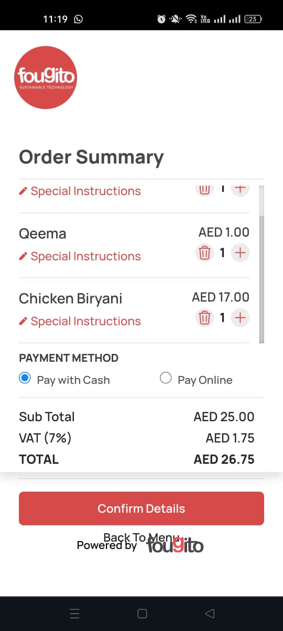

1. **Confirming Order**:
   * **Enter Details**: Users provide the following information:
     + **Full Name**: Their name.
     + **Phone Number**: Their phone number, which will be verified with an OTP.
   * **Verify Phone Number**: After entering the phone number, users will receive an OTP for verification. The number is accepted only after the correct OTP is entered.
2. **Confirm Order**: Users review all details and confirm their order.



* + **Confirmation Prompt**: After submitting the order, users receive a prompt confirming that their order has been received, with an option to visit the website.



* + - **View Order Details**: Users have the option to view detailed information about their order, including:
      * **Order Status**: The current status of the order.
      * **Order Summary**: A summary of the items ordered.
      * **Payment Info**: Payment details.
      * **Card Details**: If payment is online then the user will see the pay with wallet option and enter their credit or debit card information.
      * **Switch to Cash**: users have the option to switch to "Pay with Cash" if they prefer not to pay online.

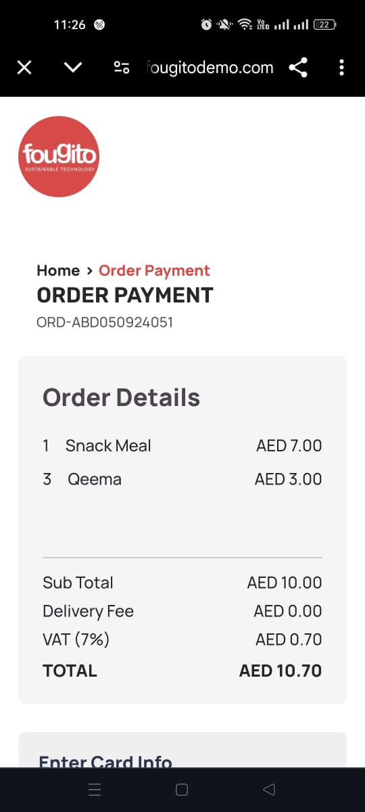 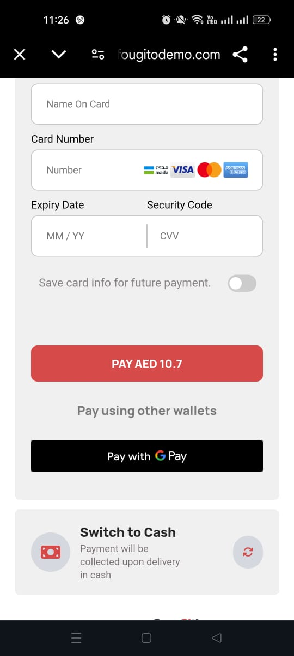

**QR Car Hop Orders**

* **Welcome Screen**:
  1. **Scan QR Code**: Users find a QR code displayed at designated car hop spots or on their car’s dashboard. They open Google or another QR code scanning app and scan the code.



* 1. **Welcome Screen**: Upon scanning the QR code, users are directed to a welcome screen with a field to enter their vehicle licence plate number.



* **Entering Vehicle Information**:
  1. **Licence Plate Number**: Users enter their vehicle’s licence plate number into the provided field.
  2. **Get Started**: After entering the licence plate number, users click the **"Get Started"** button to proceed.

**Menu and Order Placement**:

* **View Menu**: Once the license plate number is submitted, users are redirected to the menu for the restaurant’s car hop service.
  1. **Location Services**: If the user's phone location is off, they will be prompted to enable location services and click a **"Visit Website"** button.



* 1. **Location Enabled**: Once location services are enabled and the code is scanned again, the system checks if the user is within the restaurant’s designated carhop area.
     + **Within Diameter**: If the user is within the designated carhop area, the menu for the restaurant will appear on their screen.



* + - **Out of Diameter**: If the user is outside the service area, they will receive a prompt indicating they are out of the restaurant’s car hop service area and will be redirected to the website.



* **Browse Menu**: Users can browse through categories such as appetizers, main courses, and desserts.
  + - **Add Items to Cart**: Users select items and add them to their cart.



* + - * **Special Instructions**: Users can provide special instructions or customization notes for each item.



* + - **Review Cart**: Users can view their cart, adjust quantities, or remove items.
    - **Order Summary**:
      * **Sub Total**: The cost of items before taxes.
      * **VAT (fixed from restaurant’s admin portal)**: Tax details.
      * **Total**: The final amount to be paid.
* **Choose Payment Method**:
  1. **Pay with Cash**: Opt for cash payment.
  2. **Pay Online**: Opt for online payment and enter card details if selected.

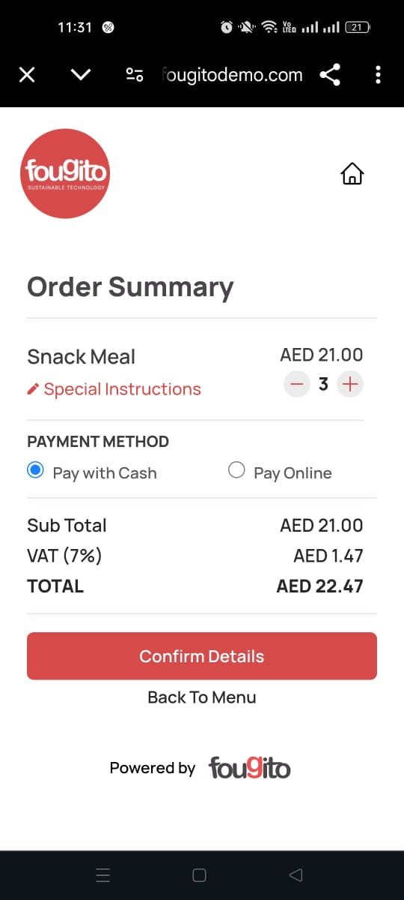

* **Confirming Order**:
  1. **Enter Details**: Users provide additional information to finalize their order:
     + **Full Name**: Their name.
     + **Phone Number**: Their phone number, which will be verified with an OTP.
     + **Location of Parked Vehicle**: The location where their vehicle is parked.
     + **Licence Plate Number**: Re-enter the vehicle’s license plate number.
  2. **Verify Phone Number**: After entering the phone number, users will receive an OTP for verification. The number is accepted only after the correct OTP is entered.
  3. **Confirm Order**: Users review all details and confirm their order.

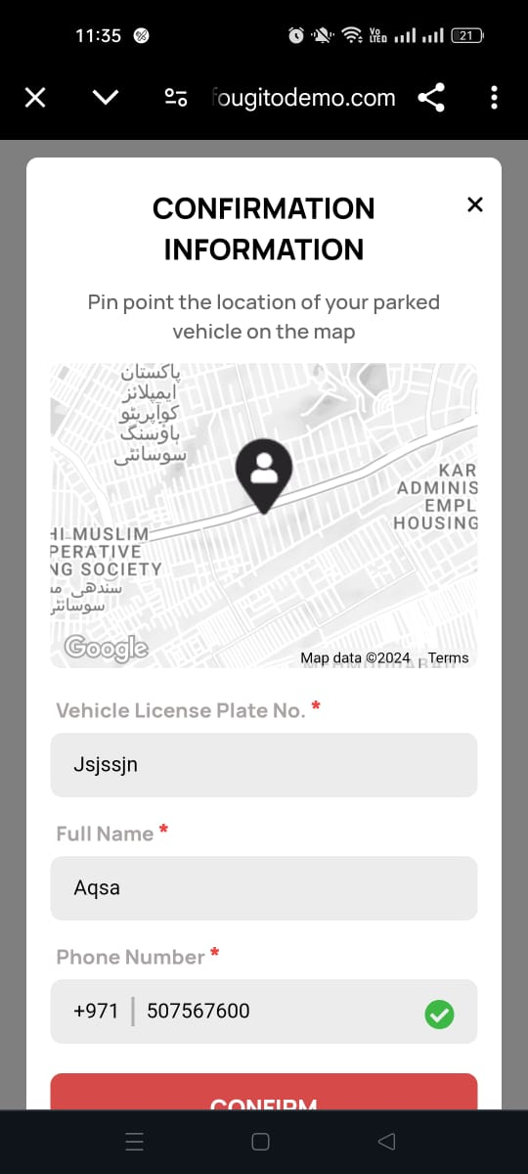

* **Order Confirmation**:
  1. **Confirmation Screen**: After submitting the order, users see an order confirmation screen with a summary of their order.



* + - **View Order Details**: Users have the option to view detailed information about their order, including:
      * **Order Status**: The current status of the order.
      * **Order Summary**: A summary of the items ordered.
      * **Payment Info**: Payment details.
      * **Card Details**: If payment is online then the user will see the pay with wallet option and enter their credit or debit card information.
      * **Switch to Cash**: users have the option to switch to "Pay with Cash" if they prefer not to pay online.

 

### 

### 

### 

### 

### 

### 

### 

### 

### 

### **QR Dine-In Orders – POS Flow**

**Waiter Flow**

#### **1. Login to Fougito Partner App**

* The waiter logs into the Fougito Partner app using their credentials.

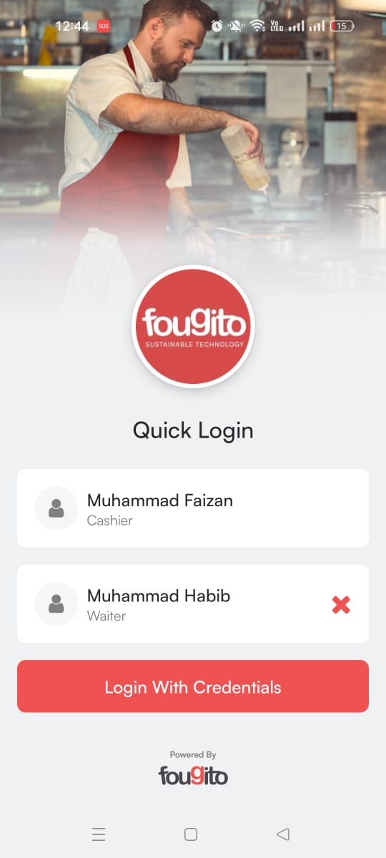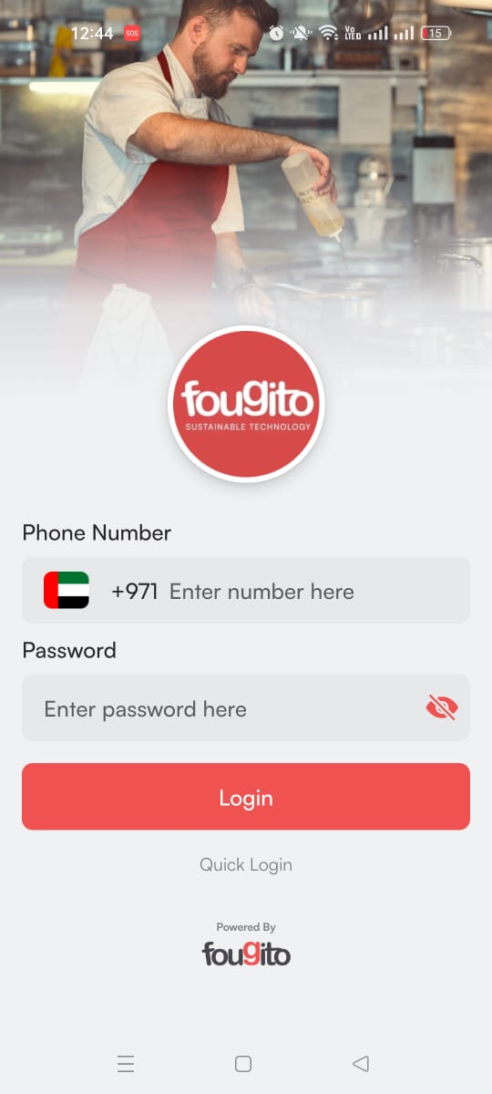

* Upon successful login, they land on the home screen.

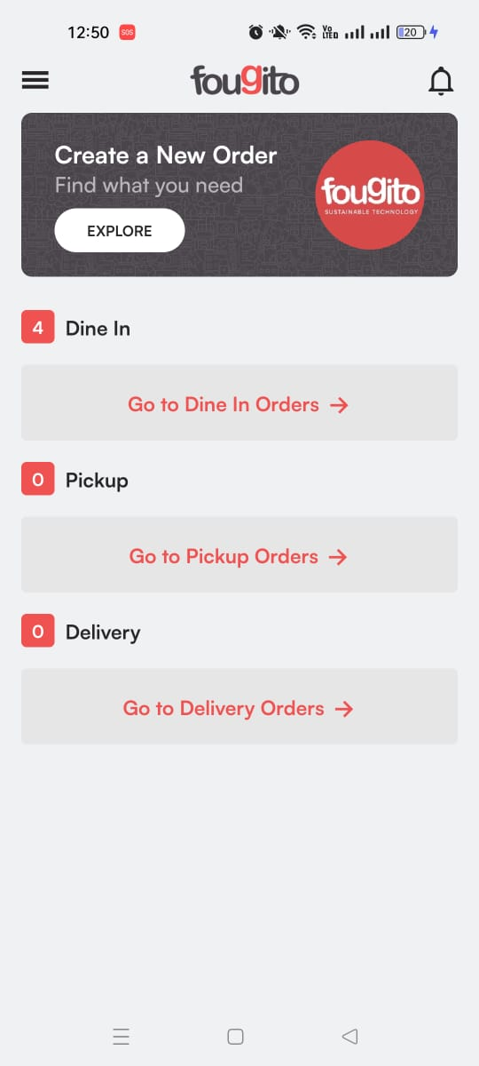

#### **2. Receive New Order Notification (If Already Logged In)**

* If the waiter is already logged into the app, they will receive a **notification** when a new QR dine-in order is punched.
* The notification informs them of the new pending order.
* They can click on the notification to directly view the new order.

**3. Navigate to Dine-in Orders**

* The waiter clicks on the "Go to Dine-in Orders" button.
* This action navigates them to the "Dine-in Orders" page, where all active dine-in orders are listed.

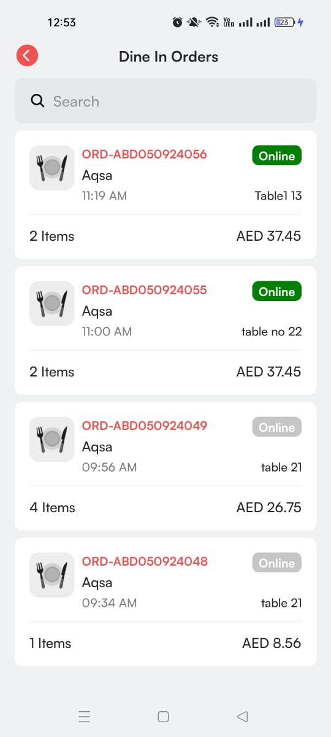

#### **4. Viewing and Searching Orders**

* On the Dine-in Orders page, a list of all dine-in orders appears.
* Each order is displayed with the following details:
  + Order ID
  + Customer Name
  + Time of Order
  + Number of Total Items
  + Table Number
  + Order Total
  + Order Status Tile (Green or Grey)
* A Search Ba**r** is available at the top for searching specific orders by customer name, order ID, or table number.

#### **5. Order Status Explanation**

* Orders can have two types of status tiles:
  + **Green Tile**: Indicates the order is **Pending** and needs action.
  + **Grey Tile**: Indicates the order is **Confirmed**.
* The waiter only needs to process orders with a green tile (Pending).



#### **6. Select Pending Order**

* The waiter identifies the pending order with the green tile and clicks on that specific order.
* Upon selection, they are navigated to the Order Detail Page.

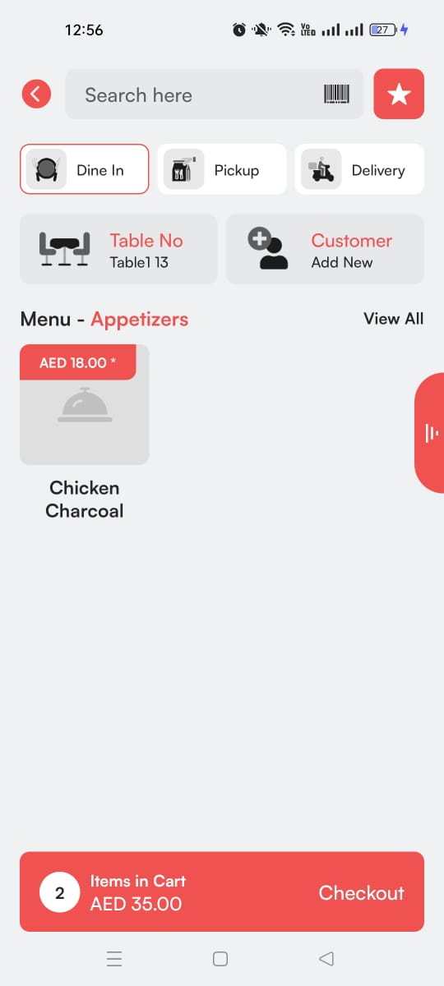

#### **7. Review Order Details**

* On the Order Detail Page, the waiter can view all relevant order details

#### **8. Checkout Process**

* At the bottom of the Order Detail Page, the waiter clicks on the **Checkout** button to proceed.
* This action takes them to the **Cart Page**.

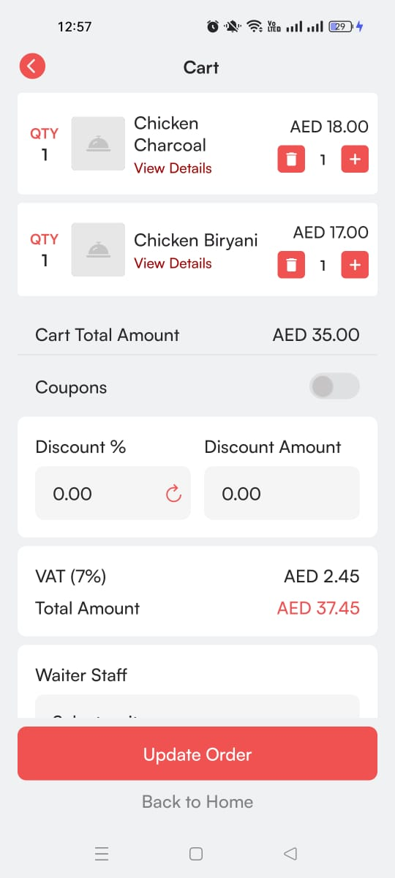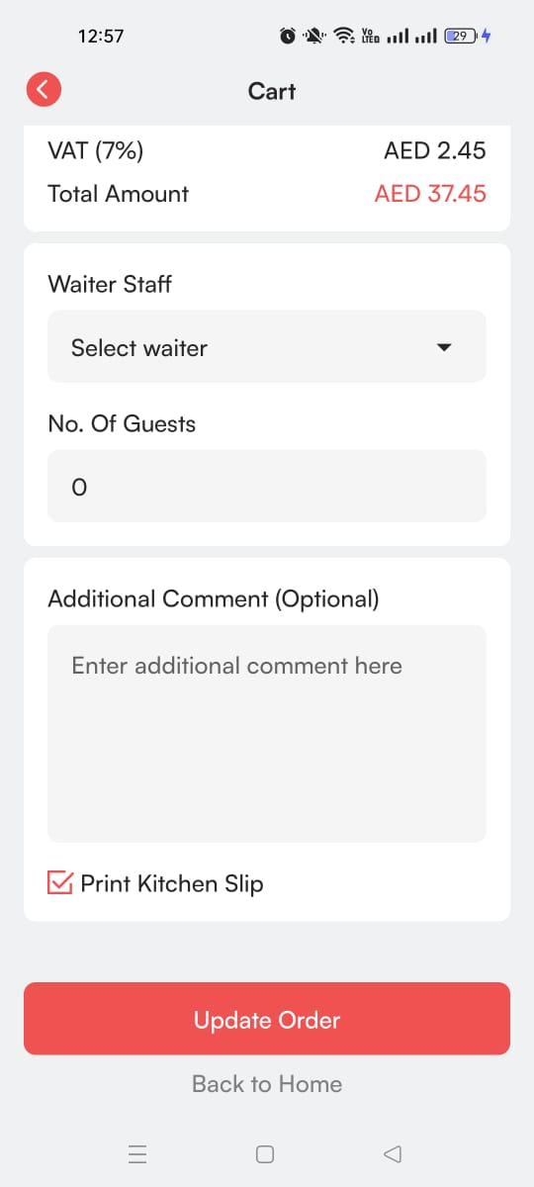

#### **9. Cart Page – Update Order**

* On the Cart Page, the system automatically populates the **Select Waiter** field with the logged-in waiter’s name by default.
* The waiter reviews the order one last time and clicks on the **Update Order** button to confirm the changes.
* After clicking the "Update Order" button, the order status changes from pending to confirmed.
* The waiter can click on back to home page which will be navigated to Dine-in orders page

#### **10. Order Confirmation**

* The waiter has successfully confirmed the pending order, and it is now marked as confirmed on the Dine-in Orders page with green tile converted into grey.

### **QR Dine-In Orders – POS Flow**

**Cashier Flow**

#### **1. Login to Fougito Partner App**

* The cashier logs into the Fougito Partner app using their credentials.



* Upon successful login, they land on the home screen.

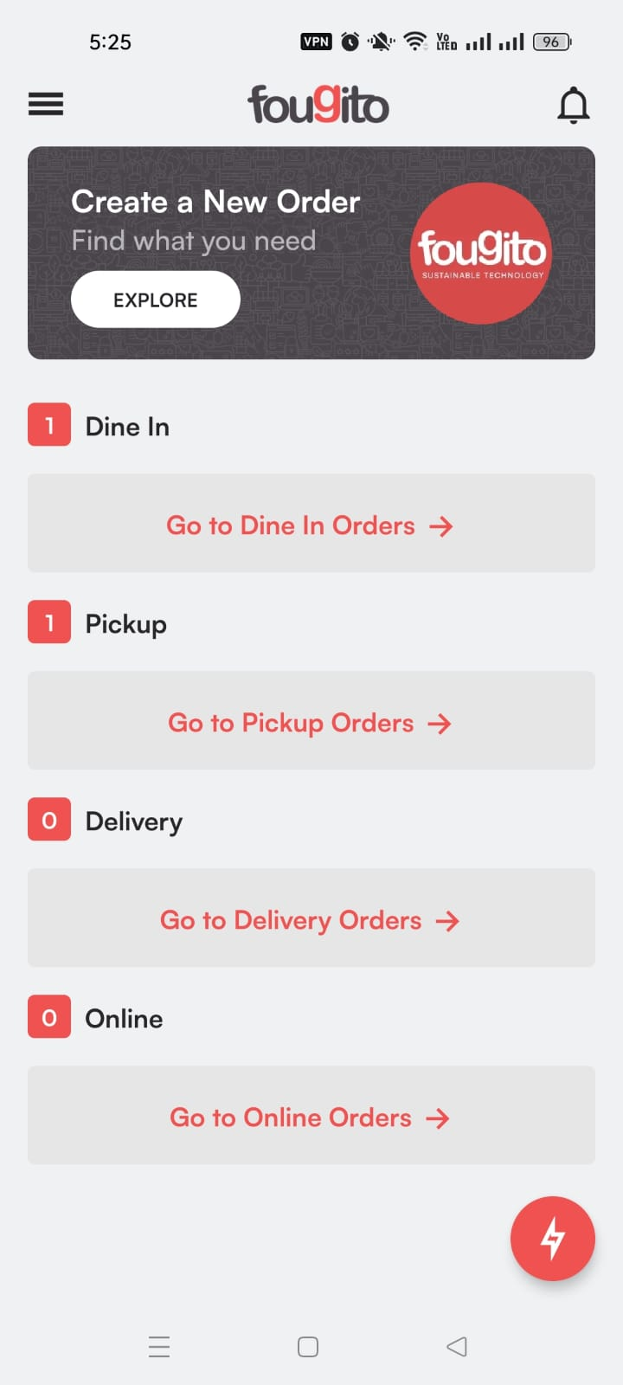

#### **2. Receive New Order Notification (If Already Logged In)**

* If the cashier is already logged into the app, they receive a notification when a new QR dine-in order is placed.

#### **3. Navigate to Dine-in Orders**

* The cashier clicks on "Go to Dine-in Orders," which navigates to the **Dine-in Orders** page, displaying all dine-in orders. Each order is shown with details like order ID, customer name, time, number of items, table number, total, and status (green for pending, grey for confirmed).



#### **4. Order Status Overview**

* The cashier can handle both pending (green tile) and confirmed (grey tile) orders.

#### **5. Assign or Update Waiter**

* The cashier can assign a waiter to a pending order by selecting one from the dropdown and confirming the assignment.

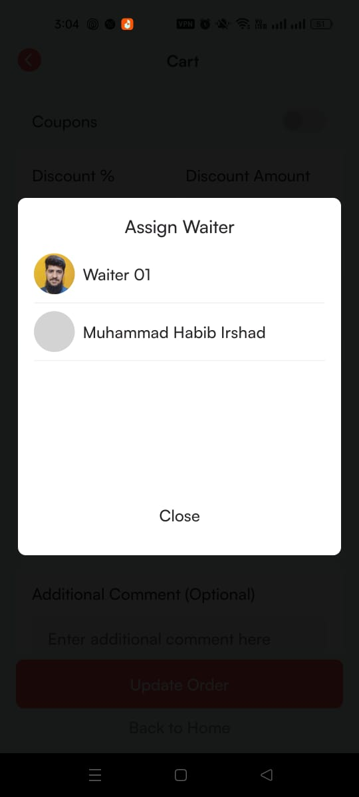

* For confirmed orders, they can update the assigned waiter by changing the selection in the dropdown and clicking **Update Order**.

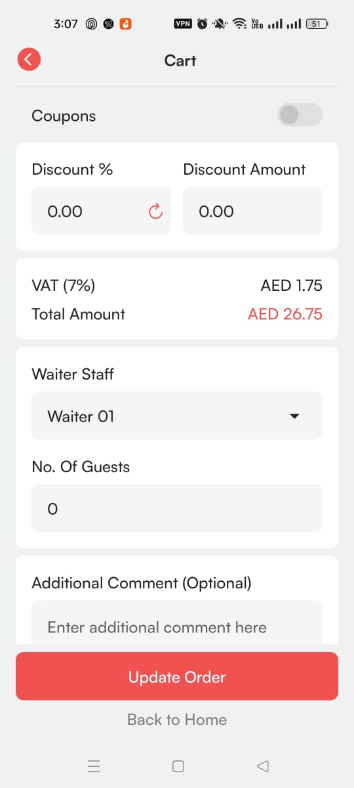

#### **6. Processing Payment**

* For confirmed orders, the cashier clicks on the order to view details and selects Proceed to Payment to navigate to the Payment Methods Page.

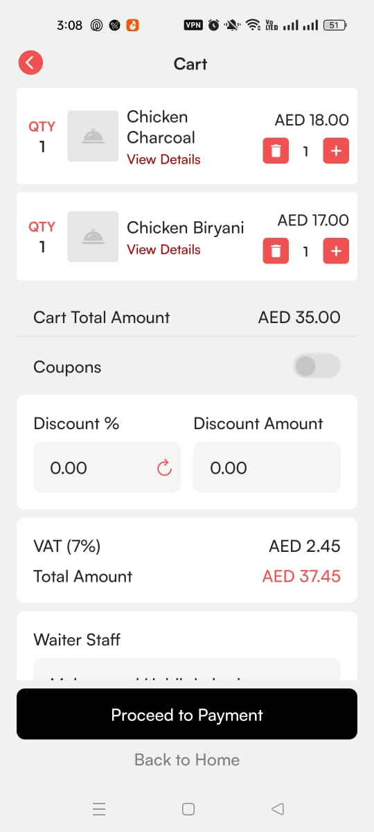

### **Payment Methods**

Once the cashier reaches the **Payment Methods Page**, they are presented with several options to finalize the payment.

**1. Cash Payment**

* In a cash transaction, the cashier records the amount received from the customer.
* If the customer gives more than the final bill amount, the cashier enters the amount of cash received and the system automatically calculates the change to be returned.
* The cashier confirms the payment by clicking **Payment Confirm**.

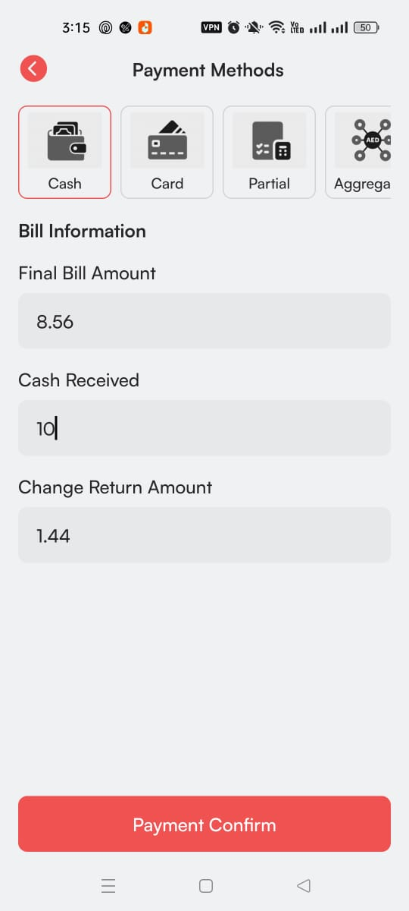

#### **2. Card Payment**

* For card payments, the cashier selects the customer’s card type (e.g., Visa, MasterCard).
* The system may generate a QR code for the card payment.
* The cashier can share via WhatsApp for the customer to complete the transaction.
* Once the payment is completed, the cashier confirms it by clicking **Payment Confirm**.

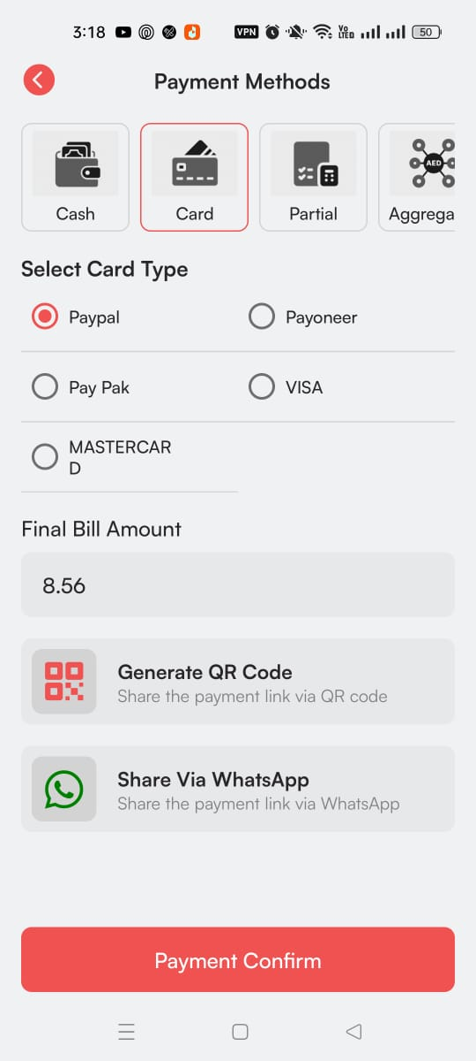

#### **3. Partial Payment**

* Partial payments allow the customer to split the payment between card and cash.
* The cashier enters the amount being paid via card and the amount paid in cash.
* If the cash amount exceeds the final bill, the system calculates the change to be returned.
* After confirming both payment types, the cashier clicks **Payment Confirm**.

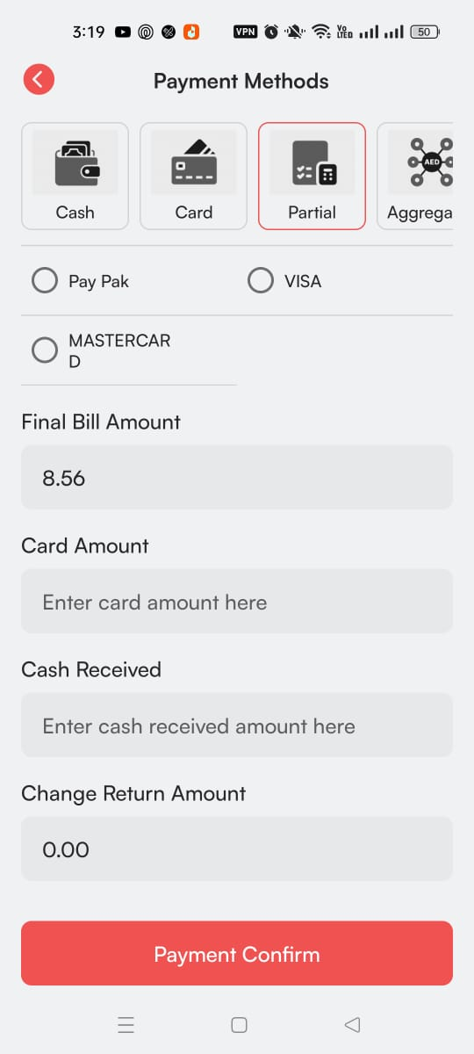

#### **4. Aggregator Payment**

* For payments through third-party aggregators (such as food delivery or payment platforms), the cashier selects the aggregator from a list.
* The cashier specifies whether the payment was made online or directly paid to the restaurant.
* After entering the payment details, the cashier confirms the transaction by clicking **Payment Confirm**.

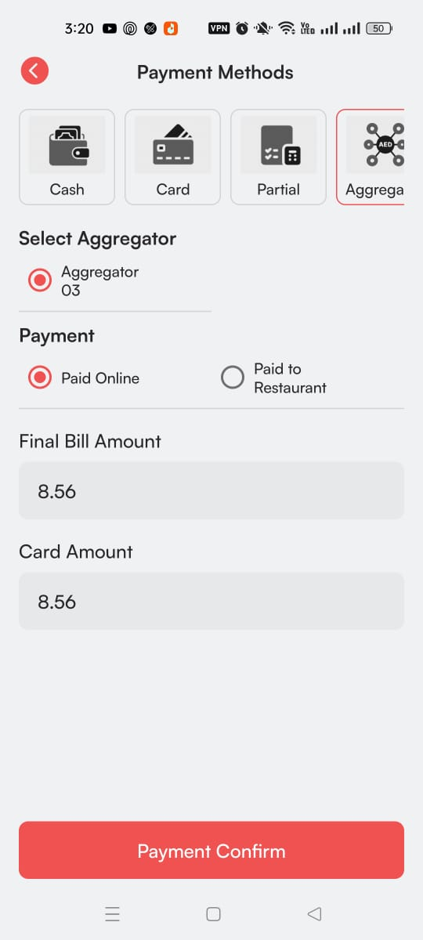

#### **5. Credit Payment**

* This method is used for regular or known customers who are allowed to pay on credit.
* The cashier enters the final bill amount and the customer’s name.
* After confirming the credit transaction by clicking **Payment Confirm**.

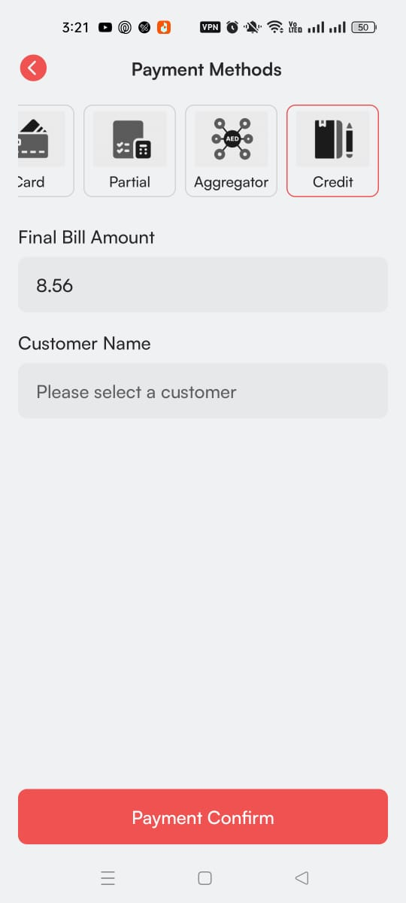

**7. Invoice Page**

* After payment confirmation, the cashier is taken to the **Invoice Page**, where they can:
  + **Share** the invoice with the customer via phone number, QR code and email

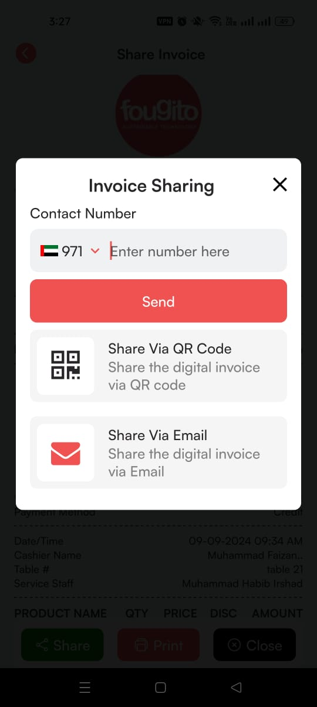

* + **Print** the invoice for the customer.
  + **Close** the order and return to the Dine-in Orders page.

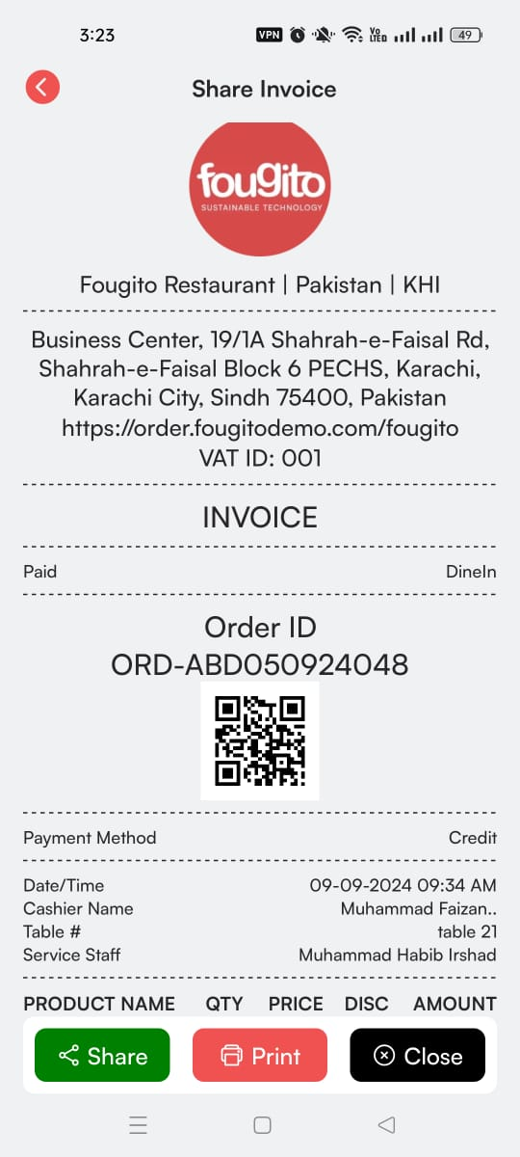

### **8. Order Removal**

* Once the payment is successfully processed, the order is automatically removed from the dine-in Orders page, indicating the transaction is complete.

### **Online Orders – POS Flow**

### **Service Staff Flow**

### **1. Login to Fougito Partner App**

* The service staff logs into the Fougito Partner app with their credentials.



* After logging in, they see the **Welcome Screen** with a button ‘Go to Online Orders’.

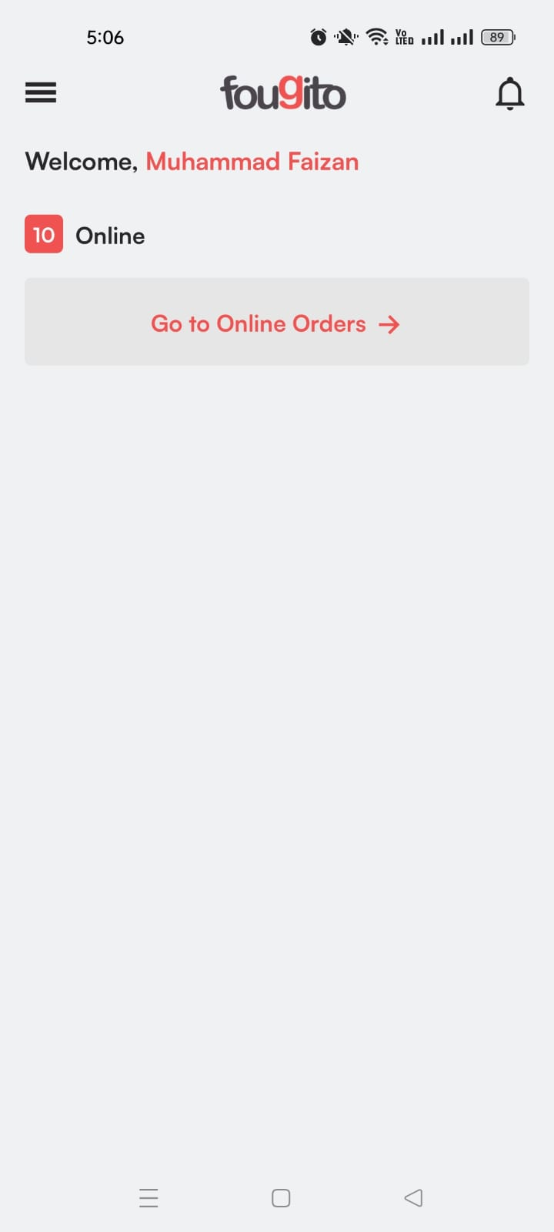

#### **2. Navigate to Online Orders**

* The service staff clicks the Go to Online Orders button, which navigates them to the Online Orders Page.
* The page lists all online orders with key details like:
  + Order ID
  + Customer Name
  + Time
  + Order Status
  + Order Total
  + Order Type Tile (Delivery, Pickup, Car Number, Room No.)
* The service staff can also use the Search Bar to search specific orders.

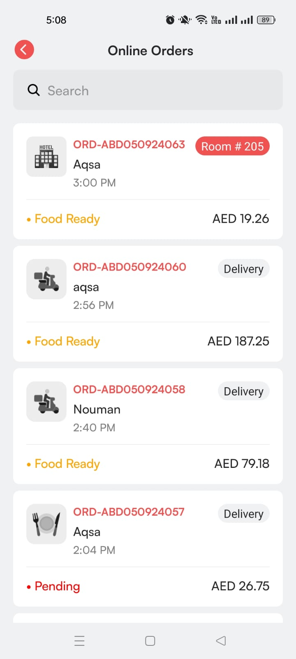

**3. Types of Orders**

* There are four types of online orders, each represented by a distinct tile:
  1. Delivery
  2. Pickup
  3. QR Room Orders
  4. Carhop Orders

### **Delivery Orders Flow**

#### **1. View Delivery Order**

* In the Online Orders Page, delivery orders are marked with a **Delivery Tile**.

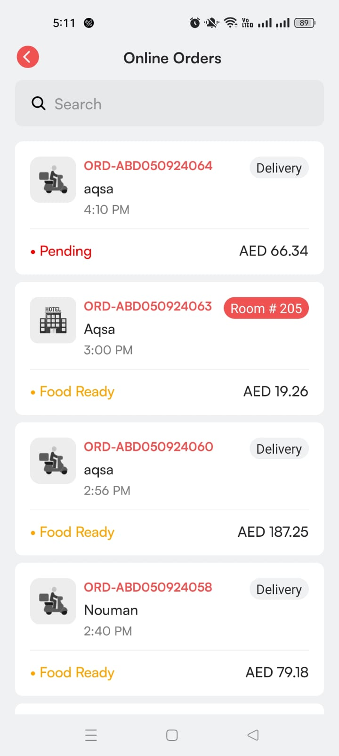

* The service staff clicks on the order, which navigates them to the Order Detail Page.

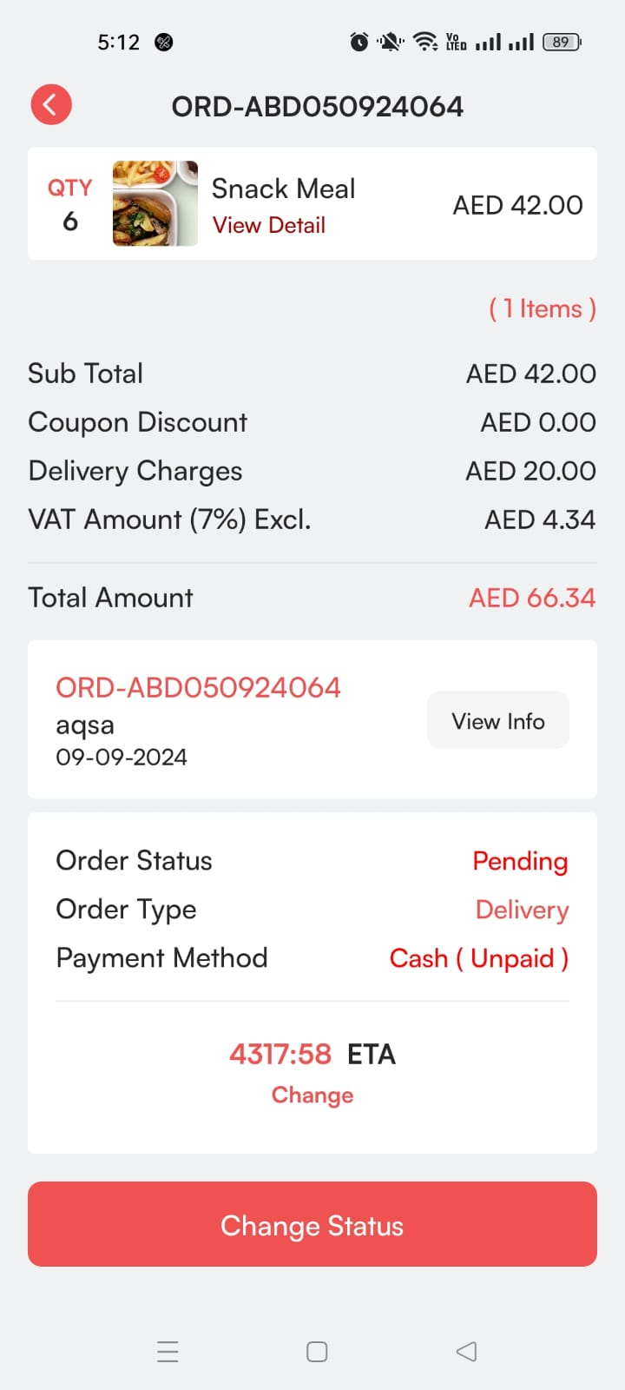

#### **2. Change Order Status to Confirmed**

* On the Order Detail Page, there is a Change Status button.
* Initially, the order status is Pending. The service staff changes it to Confirmed and clicks Update.

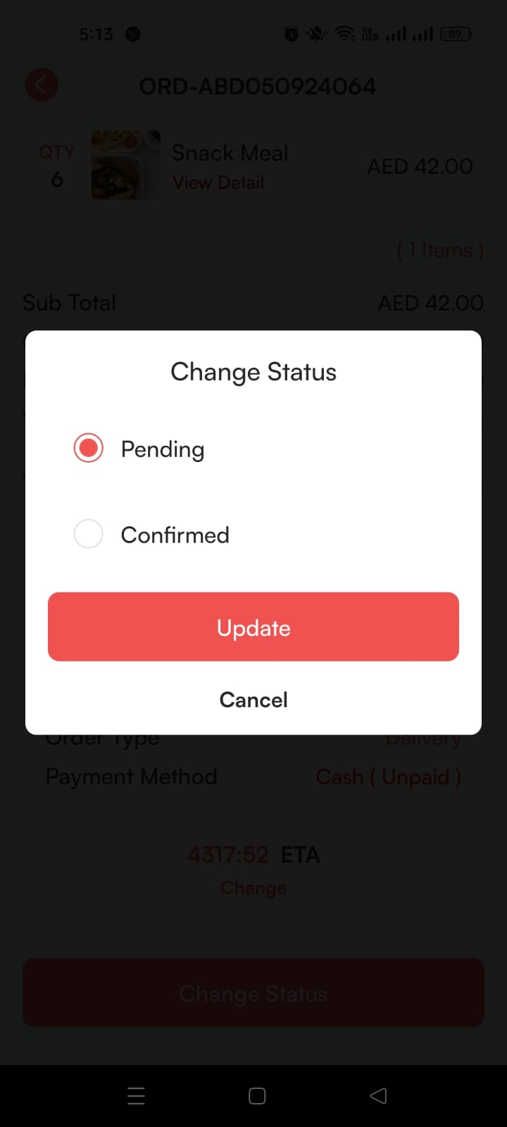

* The order status is now updated.

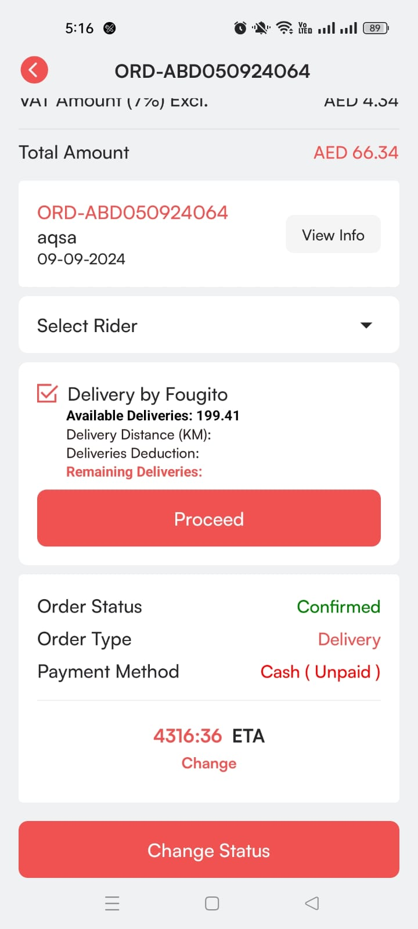

#### **3. Assign Rider**

* Once the order is confirmed, the service staff can assign a rider by selecting a rider from the Select Rider dropdown.

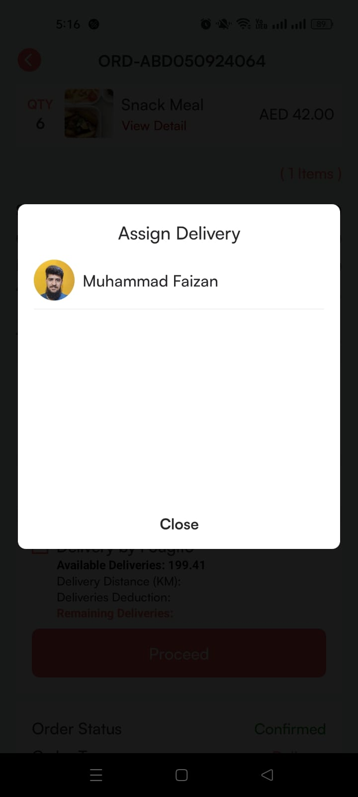

* If deliveries are handled through ‘deliver by Fougito’, the service staff can check broadcasting flow. And if the Fougito rider is not available, then service staff can restart the broadcasting flow.



* After assigning the rider, The service staff can change the status to Ready and click Update.

#### 

* The order status is now updated.

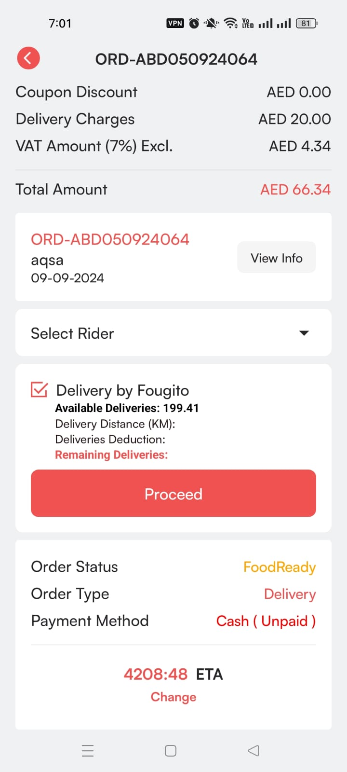

#### **4. Reassign Rider:** Service staff can also reassign the rider at any point

#### **5. Ready Status and Completion**

* Ready is the last status for service staff. The rider will take over and deliver the order.
* Once the rider completes the delivery, the order status is updated, and the order is removed from the online order list.

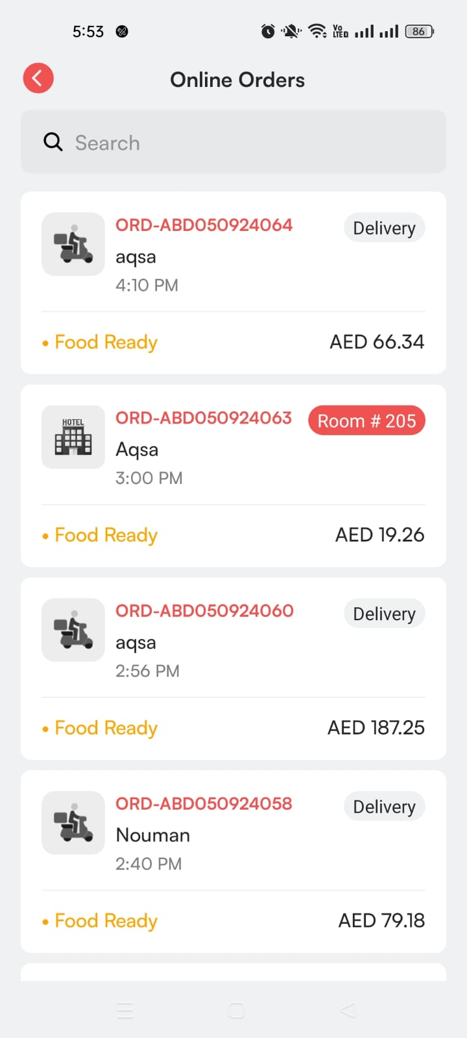

### **Pickup Orders Flow**

#### **1. View Pickup Order**

* Pickup orders are marked with a Pickup Tile on the Online Orders Page.
* The service staff clicks on the order to navigate to the Order Detail Page.

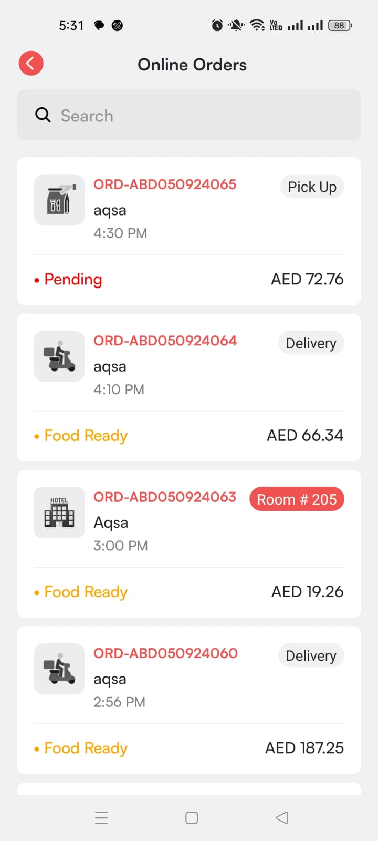

#### **2. Change Order Status to Confirmed**

* On the Order Detail Page, the order status starts as Pending. The service staff changes the status to Confirmed and clicks Update.



* The order status is now confirmed.

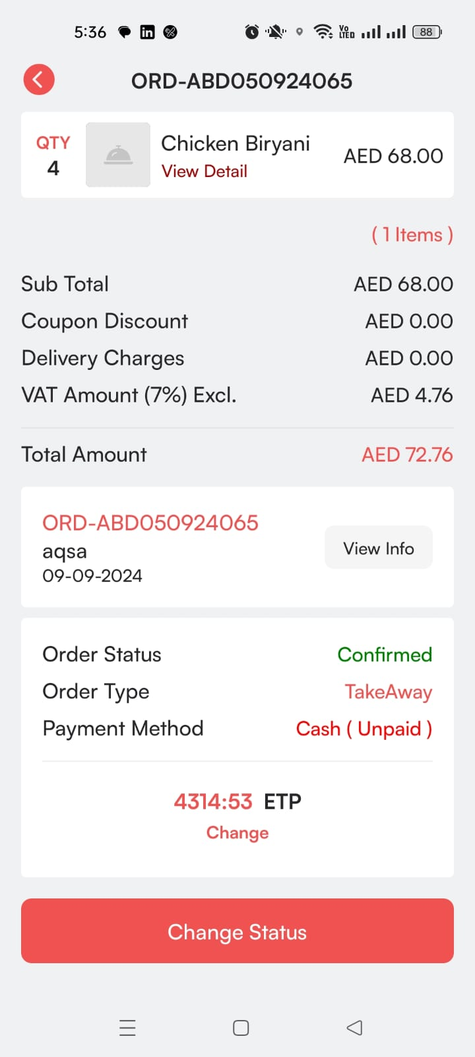

#### **3. Change Order Status to Ready**

* After confirming the order, the service staff changes the status to Ready.

#### 

* Once the order is marked as ready, the Mark as Delivered and cancel button appears on the Order Detail Page.

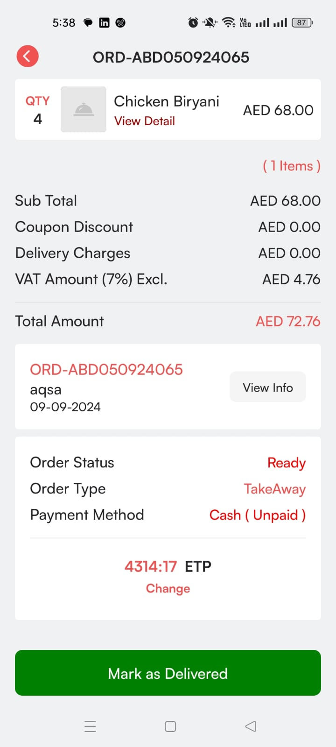

#### **4. Complete the Pickup Order**

* The service staff clicks Mark as Delivered to complete the order.

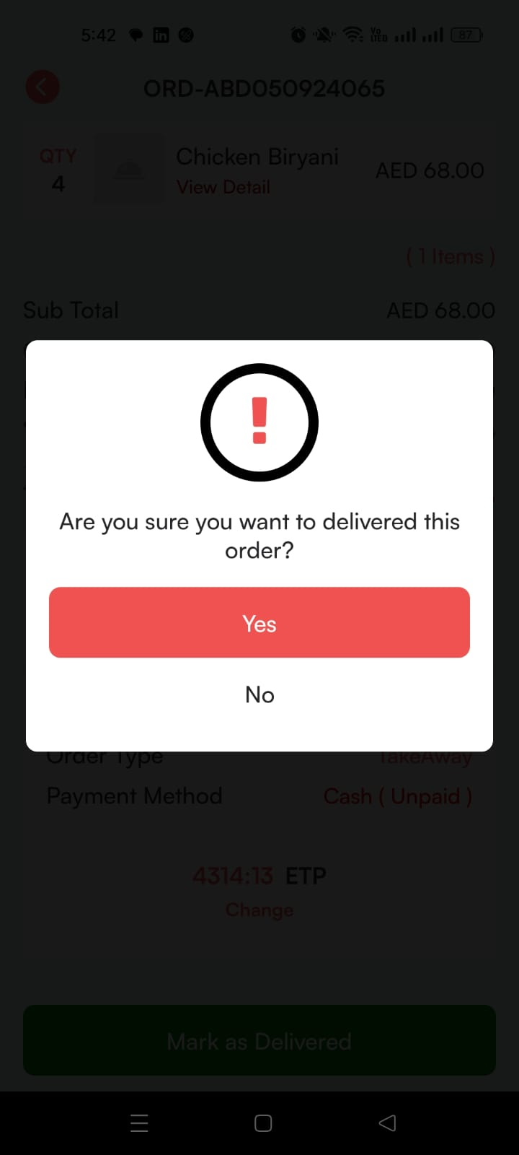

* After marking it as delivered, the order is removed from the online orders list.
* The service staff can also cancel the order due to any reason.

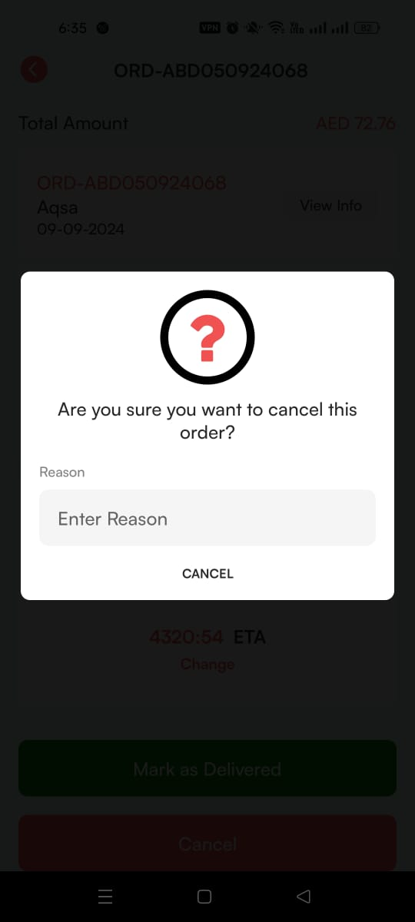

### **Room Orders Flow**

#### **1. View Room Order**

* Room orders are marked with a Room No. Tile in the Online Orders Page.

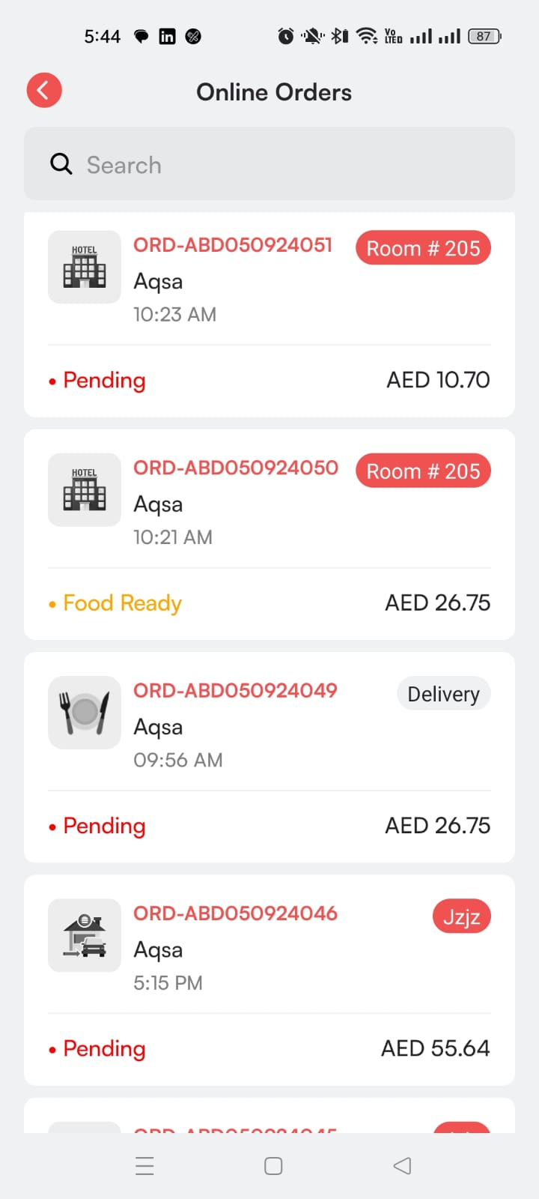

* The service staff clicks on the order to navigate to the Order Detail Page.

#### **2. Change Order Status to Confirmed**

* On the Order Detail Page, the initial status is Pending. The service staff changes the status to Confirmed and clicks Update.



#### **3. Assign Rider**

* After confirming the order, the service staff assigns a rider from the Select Rider dropdown.



* Once the rider is assigned, the order status changes to Ready

**4. Reassign Rider:** Service staff can also reassign the rider at any point

#### **5. Ready Status and Completion**

* After the order is marked as Ready, the rider will complete the delivery.
* The rider will close the order after delivery, and the status is updated in the system, removing it from the online orders page.

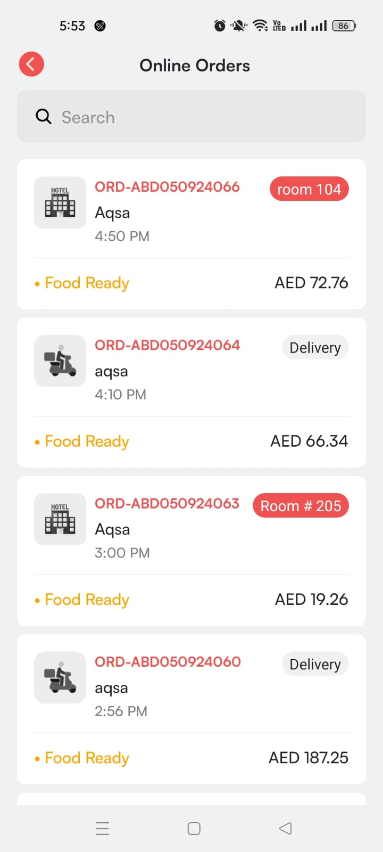

### **Carhop Orders Flow**

#### **1. View Carhop Order**

* Carhop orders are marked with a Car Number Tile on the Online Orders Page.
* The service staff clicks on the order to navigate to the Order Detail Page.

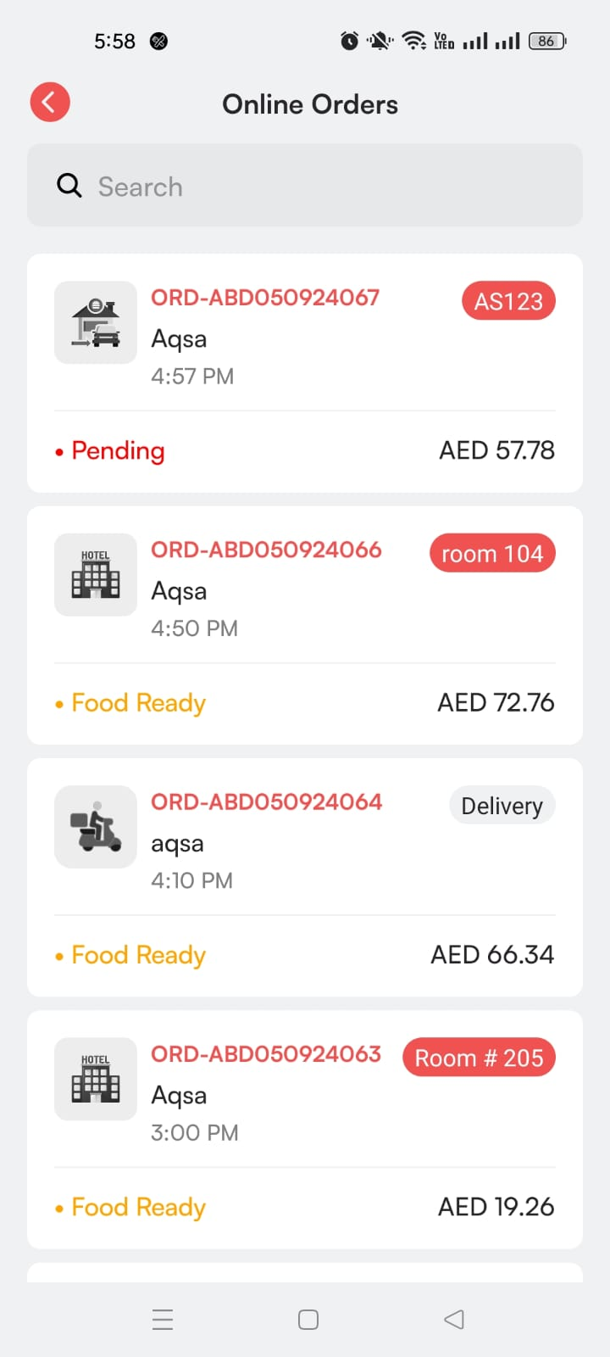

#### **2. Select Waiter**

* Carhop orders include an additional Waiter Dropdown, where the service staff can assign a waiter to the order before or after updating the status.

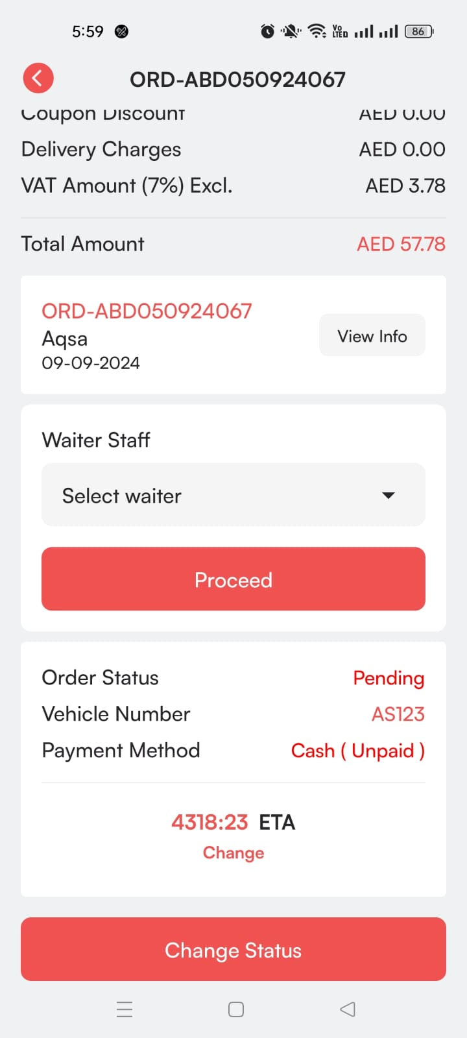 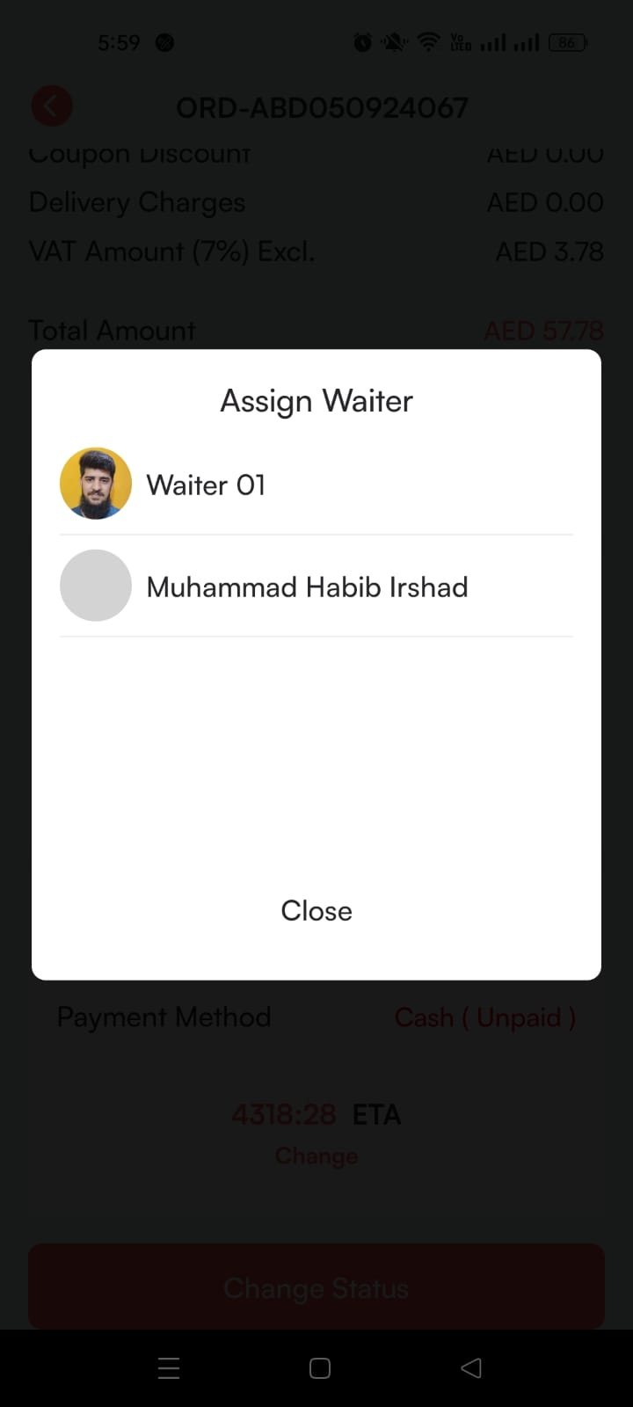

#### **3. Change Order Status to Confirmed**

* On the Order Detail Page, the initial status is Pending. The service staff changes the status to Confirmed and clicks Update.



* The order is now confirmed.

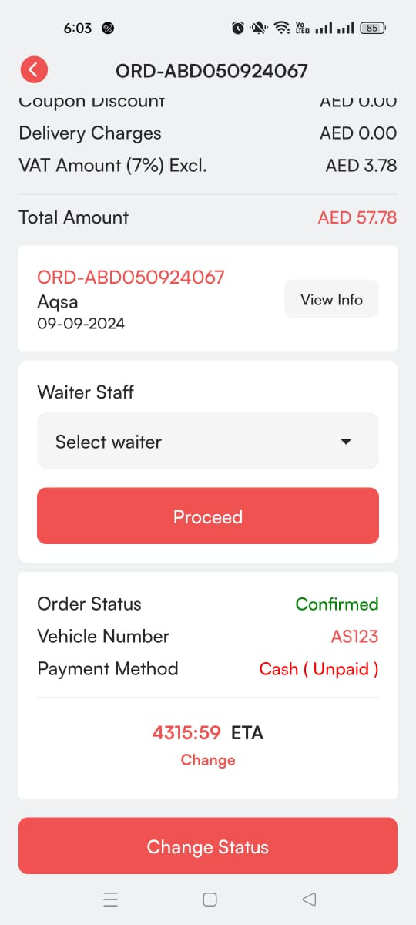

#### **4. Change Order Status to Ready**

* After confirming the order, the service staff can change the status to Ready.

#### 

**5. Reassign Rider:** Service staff can also reassign the waiter at any point

#### **6. Mark as Delivered**

* After the order is ready, Mark as Delivered and cancelled appears on the Order Detail Page.

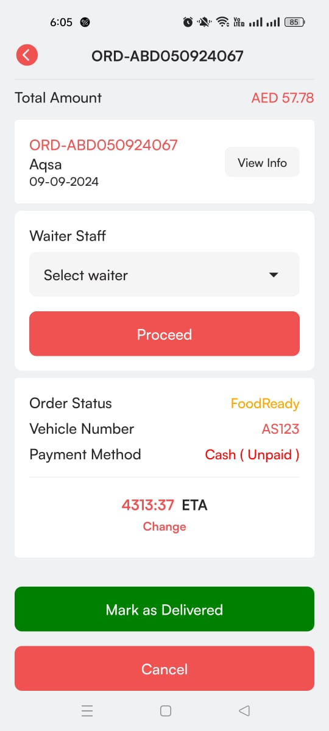

* The service staff marks the order as delivered, and the order is removed from the online orders list.



* The service staff can also cancel the order due to any reason.



### 

### 

### 

### 

### 

### 

### 

### 

### **Online Orders – POS Flow**

**Cashier Flow**

#### **1. Login to Fougito Partner App**

* The cashier logs into the Fougito Partner app using their credentials.



* Upon successful login, they land on the home screen.

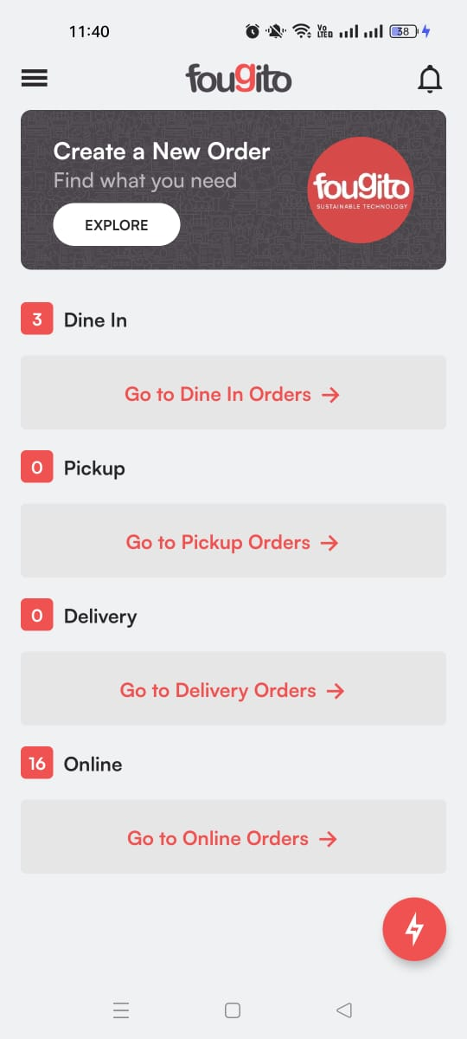

#### **2. Receive New Order Notification (If Already Logged In)**

* If the cashier is already logged into the app, they receive a notification when a new online order is placed.

#### **3. Online Orders Page**

* The cashier clicks Go to Online Orders to navigate to the Online Orders Page.
* The page lists all online orders with key details like:
  + Order ID
  + Customer Name
  + Time
  + Order Status
  + Order Total
  + Order Type Tile (Delivery, Pickup, Car Number, Room No.)
* A **Search Bar** is also available for quick searches.



#### **4. Types of Orders**

* The four types of online orders:
  1. Delivery Orders
  2. Pickup Orders
  3. QR Room Orders
  4. Carhop Orders

### **1. Delivery Orders Flow**

#### **a. View Delivery Order**

* The cashier clicks on the delivery order marked with a Delivery Tile.



* The cashier is navigated to the Order Detail Page.



#### **b. Change Status to Confirmed**

* The initial status is Pending. The cashier changes it to Confirmed and clicks Update.



* The order status is now updated.



#### **c. Assign a Rider**

* The cashier assigns a rider via the Select Rider dropdown.



* The Delivery Boy Cash field appears once the rider is assigned. The cashier can update the petty cash.

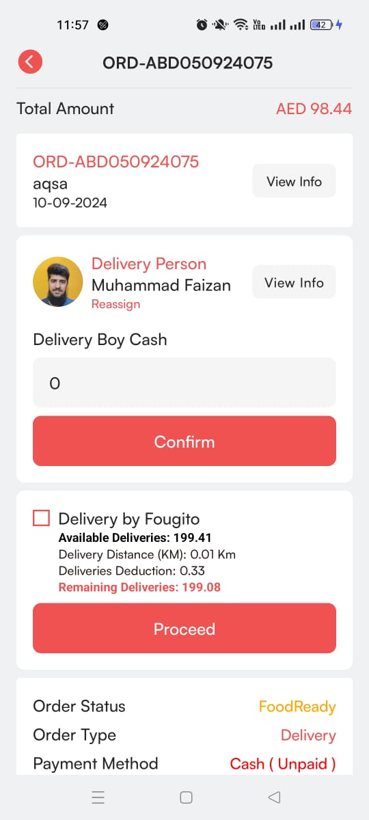

* If deliveries are handled through ‘deliver by Fougito’, the service staff can check broadcasting flow. And if the Fougito rider is not available, then service staff can restart the broadcasting flow.



* After assigning the rider, the order status will automatically updated to ready with proceed to payment button.

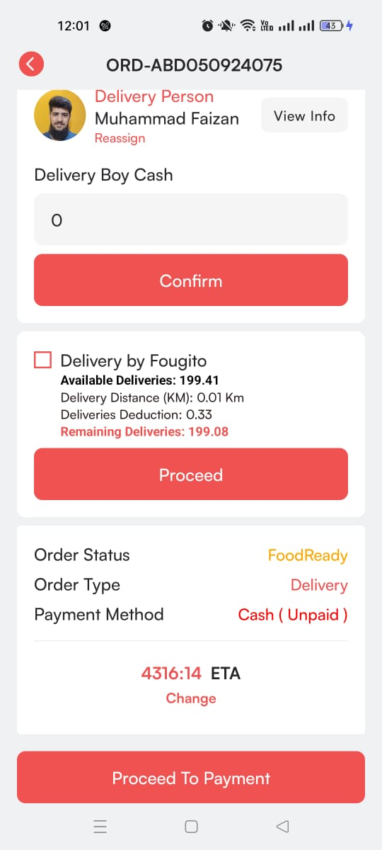

* **Reassign rider:** Cashier can also reassign the rider at any point

#### **d. Proceed to Payment**

* The cashier then clicks Proceed to Payment, navigating to the Payment Methods Page.

#### **e. Payment Methods**

Once the cashier reaches the **Payment Methods Page**, they are presented with several options to finalize the payment.

**1. Cash Payment**

* In a cash transaction, the cashier records the amount received from the customer.
* If the customer gives more than the final bill amount, the cashier enters the amount of cash received and the system automatically calculates the change to be returned.
* The cashier confirms the payment by clicking **Payment Confirm**.



#### **2. Card Payment**

* For card payments, the cashier selects the customer’s card type (e.g., Visa, MasterCard).
* The system may generate a QR code for the card payment.
* The cashier can share via WhatsApp for the customer to complete the transaction.
* Once the payment is completed, the cashier confirms it by clicking **Payment Confirm**.



#### **3. Partial Payment**

* Partial payments allow the customer to split the payment between card and cash.
* The cashier enters the amount being paid via card and the amount paid in cash.
* If the cash amount exceeds the final bill, the system calculates the change to be returned.
* After confirming both payment types, the cashier clicks **Payment Confirm**.



#### **4. Aggregator Payment**

* For payments through third-party aggregators (such as food delivery or payment platforms), the cashier selects the aggregator from a list.
* The cashier specifies whether the payment was made online or directly paid to the restaurant.
* After entering the payment details, the cashier confirms the transaction by clicking **Payment Confirm**.



#### **5. Credit Payment**

* This method is used for regular or known customers who are allowed to pay on credit.
* The cashier enters the final bill amount and the customer’s name.
* After confirming the credit transaction by clicking **Payment Confirm**.



#### **f. Complete Payment and Invoice**

* After confirming the payment, the cashier is taken to the Invoice Page, where the invoice can be printed, shared, or closed.



* The order is removed from the Online Orders Page.

### **2. Pickup Orders Flow**

#### **a. View Pickup Order**

* Pickup orders are marked with a Pickup Tile.
* The cashier clicks the order and navigates to the Order Detail Page.



#### **b. Change Status to Confirmed**

* The status starts as Pending. The cashier changes it to Confirmed and clicks Update.



* The order status is now confirmed.



#### **c. Change Status to Ready**

* After confirmation, the cashier updates the status to Ready.

#### 

* Once the order is marked as ready, the Mark as Delivered and cancel button appears on the Order Detail Page.

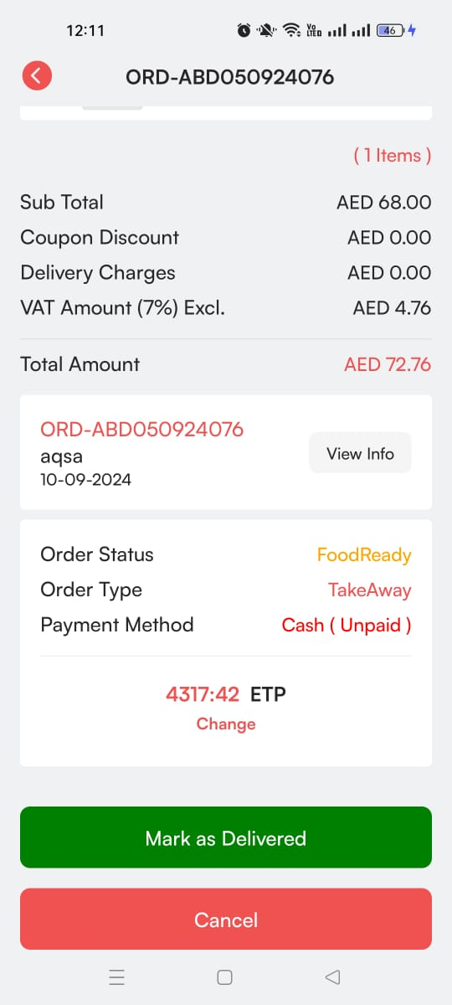

#### **d. Complete the Pickup Order**

* The cashier clicks Mark as Delivered to complete the order.



* After marking it as delivered, the payment button will appear.
* The cashier can only cancel the order before ‘marked as delivered’ due to any reason.



#### **Proceed to Payment**

* The cashier then clicks Proceed to Payment, navigating to the Payment Methods Page.

#### **e. Payment Methods**

Once the cashier reaches the **Payment Methods Page**, they are presented with several options to finalize the payment.

**1. Cash Payment**

* In a cash transaction, the cashier records the amount received from the customer.
* If the customer gives more than the final bill amount, the cashier enters the amount of cash received and the system automatically calculates the change to be returned.
* The cashier confirms the payment by clicking **Payment Confirm**.



#### **2. Card Payment**

* For card payments, the cashier selects the customer’s card type (e.g., Visa, MasterCard).
* The system may generate a QR code for the card payment.
* The cashier can share via WhatsApp for the customer to complete the transaction.
* Once the payment is completed, the cashier confirms it by clicking **Payment Confirm**.



#### **3. Partial Payment**

* Partial payments allow the customer to split the payment between card and cash.
* The cashier enters the amount being paid via card and the amount paid in cash.
* If the cash amount exceeds the final bill, the system calculates the change to be returned.
* After confirming both payment types, the cashier clicks **Payment Confirm**.



#### **4. Aggregator Payment**

* For payments through third-party aggregators (such as food delivery or payment platforms), the cashier selects the aggregator from a list.
* The cashier specifies whether the payment was made online or directly paid to the restaurant.
* After entering the payment details, the cashier confirms the transaction by clicking **Payment Confirm**.



#### **5. Credit Payment**

* This method is used for regular or known customers who are allowed to pay on credit.
* The cashier enters the final bill amount and the customer’s name.
* After confirming the credit transaction by clicking **Payment Confirm**.



#### 

#### **f. Complete Payment and Invoice**

* After confirming the payment, the cashier is taken to the Invoice Page, where the invoice can be printed, shared, or closed.



* The order is removed from the Online Orders Page.

### **3. Room Orders Flow**

#### **a. View Room Order**

* Room orders are marked with a Room No. Tile on the Online Orders Page.
* The cashier clicks the order and is navigated to the Order Detail Page.



#### **b. Change Status to Confirmed**

* The initial status is Pending. The cashier changes the status to Confirmed and clicks Update.



#### **c. Assign a Rider**

* After confirming the order, the service staff assigns a rider from the Select Rider dropdown.



* The Delivery Boy Cash field appears once the rider is assigned. The cashier can update the petty cash.

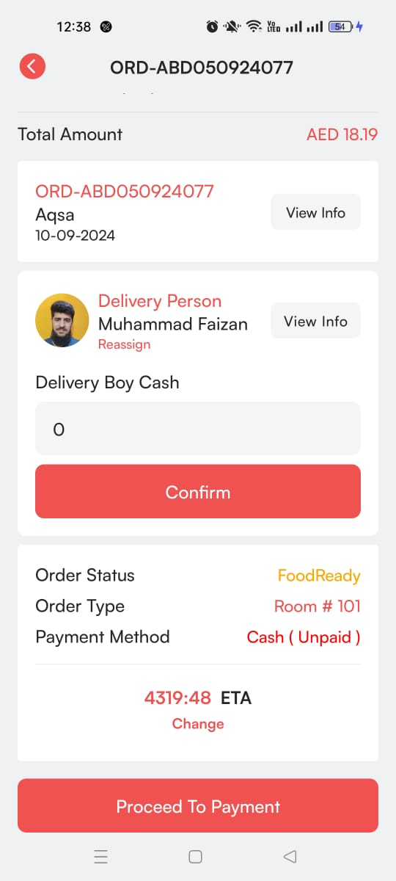

* After assigning the rider, the order status will automatically update to ready with proceed to the payment button.

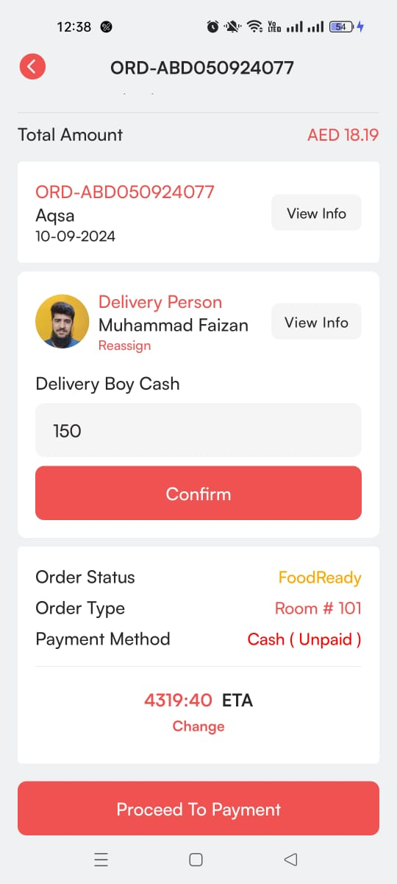

#### **Reassign rider**: Cashier staff can also reassign the rider at any point

#### **d. Proceed to Payment**

* The cashier then clicks Proceed to Payment, navigating to the Payment Methods Page.

#### **e. Payment Methods**

Once the cashier reaches the **Payment Methods Page**, they are presented with several options to finalize the payment.

**1. Cash Payment**

* In a cash transaction, the cashier records the amount received from the customer.
* If the customer gives more than the final bill amount, the cashier enters the amount of cash received and the system automatically calculates the change to be returned.
* The cashier confirms the payment by clicking **Payment Confirm**.



#### **2. Card Payment**

* For card payments, the cashier selects the customer’s card type (e.g., Visa, MasterCard).
* The system may generate a QR code for the card payment.
* The cashier can share via WhatsApp for the customer to complete the transaction.
* Once the payment is completed, the cashier confirms it by clicking **Payment Confirm**.



#### **3. Partial Payment**

* Partial payments allow the customer to split the payment between card and cash.
* The cashier enters the amount being paid via card and the amount paid in cash.
* If the cash amount exceeds the final bill, the system calculates the change to be returned.
* After confirming both payment types, the cashier clicks **Payment Confirm**.



#### **4. Aggregator Payment**

* For payments through third-party aggregators (such as food delivery or payment platforms), the cashier selects the aggregator from a list.
* The cashier specifies whether the payment was made online or directly paid to the restaurant.
* After entering the payment details, the cashier confirms the transaction by clicking **Payment Confirm**.



#### **5. Credit Payment**

* This method is used for regular or known customers who are allowed to pay on credit.
* The cashier enters the final bill amount and the customer’s name.
* After confirming the credit transaction by clicking **Payment Confirm**.



#### 

#### **f. Complete Payment and Invoice**

* After confirming the payment, the cashier is taken to the Invoice Page, where the invoice can be printed, shared, or closed.



* The order is removed from the Online Orders Page.

### **4. Carhop Orders Flow**

#### **a. View Carhop Order**

* Carhop orders are identified by a Car Number Tile on the Online Orders Page.
* The cashier clicks the order and navigates to the Order Detail Page.



#### **b. Assign a Waiter**

* Carhop orders include Waiter Dropdown, where the cashier can assign a waiter to the order before or after updating the status.

 

#### **c. Change Status to Confirmed**

* On the Order Detail Page, the initial status is Pending. The cashier changes the status to Confirmed and clicks Update.



* The order is now confirmed.



#### **d. Change Status to Ready**

After confirming the order, the cashier updates the status to Ready.

#### 

* **Reassign waiter:** Cashier can also reassign the waiter at any point.

#### **d. Proceed to Payment**

* Once the order status is ready, the payment button will appear.

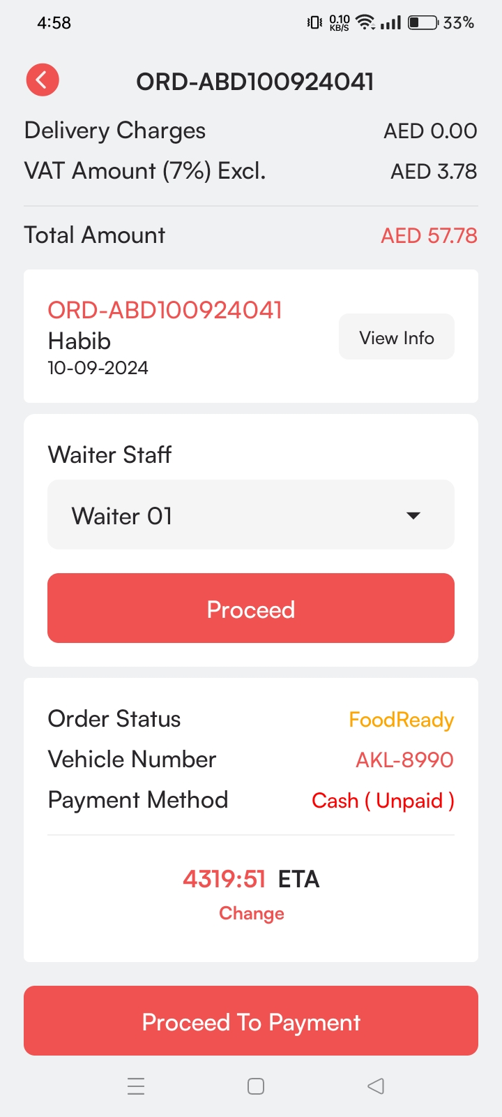

#### **e. Payment Methods**

Once the cashier reaches the **Payment Methods Page**, they are presented with several options to finalize the payment.

**1. Cash Payment**

* In a cash transaction, the cashier records the amount received from the customer.
* If the customer gives more than the final bill amount, the cashier enters the amount of cash received and the system automatically calculates the change to be returned.
* The cashier confirms the payment by clicking **Payment Confirm**.



#### **2. Card Payment**

* For card payments, the cashier selects the customer’s card type (e.g., Visa, MasterCard).
* The system may generate a QR code for the card payment.
* The cashier can share via WhatsApp for the customer to complete the transaction.
* Once the payment is completed, the cashier confirms it by clicking **Payment Confirm**.



#### **3. Partial Payment**

* Partial payments allow the customer to split the payment between card and cash.
* The cashier enters the amount being paid via card and the amount paid in cash.
* If the cash amount exceeds the final bill, the system calculates the change to be returned.
* After confirming both payment types, the cashier clicks **Payment Confirm**.



#### **4. Aggregator Payment**

* For payments through third-party aggregators (such as food delivery or payment platforms), the cashier selects the aggregator from a list.
* The cashier specifies whether the payment was made online or directly paid to the restaurant.
* After entering the payment details, the cashier confirms the transaction by clicking **Payment Confirm**.



#### **5. Credit Payment**

* This method is used for regular or known customers who are allowed to pay on credit.
* The cashier enters the final bill amount and the customer’s name.
* After confirming the credit transaction by clicking **Payment Confirm**.



#### **f. Complete Payment and Invoice**

* After confirming the payment, the cashier is taken to the Invoice Page, where the invoice can be printed, shared, or closed.



* The order is removed from the Online Orders Page.